|  |  |
| --- | --- |
|  | **MINISTRY OF EDUCATION AND TRAINING** |

|  |
| --- |
| **FPT UNIVERSITY** |

**Time and Attendance System**

Project Code: FUTAS

Project Supervisor: Phạm Thanh Tùng

Project members:

Tạ Minh Việt (VietTM1402)

Nguyễn Quang Huy (HuyNQ1087)

Đoàn Việt Anh (AnhDV968)

Trương Ngọc Sơn Tùng (TungTNS1478)

Vũ Ngọc Anh (AnhVN981)

Hà Nội, April, 2013

**Table of content**

1. **Project Introduction**
2. Initial idea of TAS project
3. Project charter
4. Overview of existing system
5. SWOT analysis
6. Improvement and benefits of expected system
7. **Project Plan**
8. Problem definition
   1. Project Description
   2. Problem abstract
   3. Project overview
9. Project organization
   1. Software process model
   2. Role and responsibilities
   3. Tools and techniques
10. Project Management Plan
    1. Task
    2. Deliverables
    3. Dependencies and Constraints
    4. Risk
11. Coding Convention
12. Quality Management
    1. Quality objectives
    2. Quality activities
13. **System Requirement**
14. Introduction
    1. Purpose
    2. Definitions and Acronyms
15. Functional requirement

2.1 Data reading

2.2 Manage shifts

2.3 Manage overtime

2.4 Manage overtime distribution

2.5 Manage shift distribution

2.6 Manage employees

2.7 Manage group employee

2.8 Manage timekeeping and payroll

2.9 Manage reader

2.10 Summary and report

1. Non-functional requirement
   1. Performance
   2. Reliability
   3. Security
   4. Availability
   5. System management
2. **System Design**
3. Design Overview
4. System Architecture Design
   1. Choice of System Architecture
   2. Discussion of Alternative Designs
   3. Description of System Interface
5. Class Diagram

3.1 Main form

3.2 Employee Management

3.3 Group Management

3.4 Shift Management

3.5 Shift Distribution Management

3.6 overtime Management

3.7 overtime Distribution Management

3.8 Reader Management

3.9 View Man-day and Salary

3.10 Report Management

1. Sequence Diagram

4.1 Employee Management

4.2 Group Management

4.3 Shift Management

4.4 Shift Distribution

4.5 Overtime Management

4.6 Overtime Distribution

4.7 Man-day

4.8 Salary

4.9 Main menu

4.10 Connect data

4.11 Read card

4.12 Change password

4.13 Report Management

1. User interface design
   1. Login
   2. Main menu
   3. Employee Management
   4. Group Management
   5. Shift Management
   6. Shift distribution
   7. Overtime Management
   8. Overtime distribution
   9. Readers Management
   10. Man-day and Salary
   11. Report Management
2. Database design
   1. Table detail
   2. Design diagram of database
3. **System Testing**
4. System introduction
   1. System overview
   2. Test approach
5. Test plan
   1. Features to be tested
   2. Features not to be tested
   3. Testing tool and environment
6. Test Cases
7. Test report
8. **User Guide**
9. Installation
10. User guide

**I. Project Introduction**

1. **Initial idea of TAS project**

Nowadays, with the development of economic, the salary of employees is rising. But the employees ’s worked hours are difficult to collect. Overpayment may be made and there can be a lot of money wasted. This is time to build a time and attendance system to calculate accurate employees ‘s performance and reduce the work involved in preparing hours for payroll

Compare with timekeeping manual using paper, time & attendance system has a lot of advantage:

* Save money and time of employers
* Accurate
* Fair
* Enhance consciousness of employees
* Increase productivity

1. **Project charter**

**Project title**: Time and Attendance System

**Project start date**: January, 7th, 2013 **Project finish date**: April, 27th, 2013

**Budget information**:

**Project manager**: VietTM,Phone:0973400809,Email:viettm01402@fpt.edu.vn

**Project objective**: developing a system to record when employees start and stop work at the department where the work is performed. The system store realistic productivity of each employee so that the companies are able to make payroll exactly.

**Roles and Responsibilities**

|  |  |  |
| --- | --- | --- |
| Role | Name | Contact Information |
| Program manager | TungPT | Tungpt@fpt.edu.vn |
| Project manager | VietTM | Viettm01402@fpt.edu.vn |
| Program technical leader | HuyNQ | Huynq01087@fpt.edu.vn |
| Developer | TungTNS | Tungtns01478@fpt.edu.vn |
| Developer | AnhDV | Anhdv00968@fpt.edu.vn |
| Tester | AnhVN | AnhVN00981@fpt.edu.vn |

1. **Overview of existing system**

**Definition**: Time and attendance systems make tracking and organizing the work hours of employees simple and straightforward. Indeed, these ‘clocking-in’ system can provide companies with the twin benefits of reducing their administration process and inspiring greater employee confidence in the accuracy of their salaries. In addition to theses benefits, investing in an attendance recording system can also help to streamline a business by indirectly increasing productivity and decreasing cost

**How it works**: Employees use a time and attendance system to clock-in and out of work whenever they start or finish a shift. This is done by swiping a unique ID which may come in the form of a barcode, magnetic stripe or pin code through a time recording device (a heading reader). Proximity cards can also be used, as these allow employees to clock-in or out by waving the card near the reader instead of swiping it through

**Type of system**: the type of attendance recording system a company chooses to purchase will depend largely upon the requirements of their own particular business. Fortunately, there are many different solutions available to suit all needs and circumstances. As well as traditional stand-alone time recorders, there are also more comprehensive solutions available which are fully compatible with HR, payroll and access control system. Indeed, sometime recording systems can cater for personal schedules, such as overtime, holidays and sick days, as well as gauge instances of lateness or absence. Even more complex system can allow companies to carry out management activities such as worker scheduling, productivity, estimating and labor forecasting. In fact, there are some systems that can even provide detailed information regarding individual work tasks or projects performed each day.

**Examples:**

-Time Management System in Fsoft: support task involved in absenteeism, be on leave, absence without salary, sick, go to work lately, leave early…Daily card scanned information is integrated with Time Management System. The system will define the leave days of employees without application or employees have application be on leave but still have scanned card information. Based on data saved in the system. Employees are able to manage, check out holidays, holidays left in the current year

* TAS-ERP Garment :
* Manage system parameter: allow users self define payroll parameter suitable with their own company
* Manage basic personnel information: Name, Position, Sex, Age, Address …
* Manage work shifts: allow register many work shifts directly in the system
* Load data & automatic calculation: load data from reading head, put into database and calculate work hours of employees
* Manage work hours of employees : allow administrators view, modified data in order to suitable with holiday registered of each employees and generate last result is daily work hours table.

1. SWOT analysis
2. **Strength**

* Help employer to track employee status (attendance, absent, late, sick …)
* Detail working hours of employees has been recorded
* Increase security
* Protect company from payroll fraud

1. **Weaknesses**

* Employees had card scanned by another employee
* Employees come in or come out without scan card

1. **Opportunities**

* Replace paper timekeeping
* Make the confidence between employees and employer increase

1. **Threats**

* Many providers
* Hard to implement in VietNam government department

1. **Improvement and benefits of expected system**
2. **Manage work shifts**

* Setup and divide work shift
* Manage work overtime

1. **Manage employees**

* Insert, delete, update employees information
* Insert, delete, update group information

1. **Manage absenteeism**

* Manage normal absenteeism
* Mange abnormal absenteeism

1. **Timekeeping, payroll**

* Connect to reading head, automatic update data into server
* Automatic payroll process
* Handle with night shifts
* Automatic calculate diligent money

1. **Sum & Report**

* Dump sum table
* Support timekeeping report management, individual attendance…

**II. Project Plan**

**1. Problem definition**

1. **Project description**

|  |  |  |  |  |  |  |
| --- | --- | --- | --- | --- | --- | --- |
| Project name : | Time and Attendance System | | | | | |
| Project Code: | FUTAS | | | | | |
| Contract Type: | Capstone Project | | | | | |
| Customer: | Vietnamese Enterprises | | | | | |
| Project level: | Company | | Branch | | | Group |
| Group: | A | | | | | |
| Division: | FPT University | | | | | |
| Project type: | External | | | Internal | | |
| Project manager: | Ta Minh Viet | | | | | |
| Project category: | New development | | Maintenance | | | Others |
| Business domain: |  | | | | | |
| Application type: | Time and attendance system for Human Resource Management | | | | | |
| Objectives and Scope | * Objectives: * Developing a system to record when employees start and stop work at the department where the work is performed * The system store realistic productivity of each employee so that the companies are able to make payroll exactly * Scope: * Group have responsibility to make requirements, detail designs, integration test cases, system test, * Do unit tests, system test * Fix bugs * Support setup & maintain | | | | | |
| Committed effort | 5 man/ month | | | | | |
| In which:  Management activities (%) | 20% | | | | | |
| Development activities (%) | 65% | | | | | |
| For Quality Assurances & Test activities (%) | 15% | | | | | |
| Project start date: | 7th January, 2013 | Expected end date: | | | 27th April, 2013 | |
| Planned duration: | 3 months |  | | |  | |

Table 1: Project Description

1. **Problem abstract**

* Build a new system replace timekeeping manual using paper. This system will include some main functions:
  + Collect work hours of each employees
  + Automatic timekeeping and generate into file Mircrosoft Word Excel
  + Manage basic employees information

1. **Project Overview**

* The proposed system

Employees use a time and attendance system to clock-in and out of work whenever they start or finish a shift. This is done by scanning a swipe card which stored data of employees on reading head. The data in reading head will be updated into server. In the end of months, work hours of each employees will be generated into file excel to make payroll. In addition, the system has ability to manage basic employee information

* 1.3.4. Development Environment
* Microsoft window server, window 7, window XP

**2. Project Organization**

* 1. **Software process model**

This project process model uses waterfall model. Waterfall is not new; it’s software development that proceeds sequentially through a series of phases, starting with system requirements analysis and leading up to product release and maintenance in software development. Feedback loops exist between each phase, so that as new information is uncovered or problems are discovered, it is possible to "go back" a phase and make appropriate modification. Progress "flows" from one stage to the next, much like the waterfall that gives the model its name.In general, the model may be considered as having six distinct phases, described below:

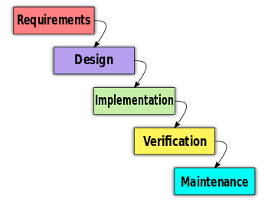

* Requirements : analyzing requirements, recording requirements, create documents and review
* Design : after the purpose and specifications of software are determined, developers will design component, architecture, algorithm, database, coding language …
* Implementation : coding, do unit test and review code
* Verification : quality assurance and testing (create test case, do unit test and system test), create report document
* Maintenance : modify software after delivery, improve performance and other attributes
  1. **Role and Responsibilities**

|  |  |  |
| --- | --- | --- |
| Role | Name | Contact Information |
| Program manager | TungPT | Tungpt@fpt.edu.vn |
| Project manager | VietTM | Viettm01402@fpt.edu.vn |
| Program technical leader | HuyNQ | Huynq01087@fpt.edu.vn |
| Developer | TungTNS | Tungtns01478@fpt.edu.vn |
| Developer | AnhDV | Anhdv00968@fpt.edu.vn |
| Tester | AnhVN | AnhVN00981@fpt.edu.vn |

Table 2: Roles and Responsibilities

* 1. **Tools and techniques**
* Microsoft Visual Studio 2010
* C# & .Net
* Microsoft SQL server 2008
* Git Hub

**3. Project Management Plan**

1. **Task**

<Refer file attached: FUTAS.MPP>

Deliverables

|  |  |  |  |  |
| --- | --- | --- | --- | --- |
| No | Deliverable | Delivery date | Delivery Location | Note |
| 1 | Software Project Plan | 21st Jan,2013 |  |  |
| 2 | Schedule-v1.0 | 21st Jan,2013 |  |  |
| 3 | Software Design Detail | 18th Feb, 2013 |  |  |
| 4 | Test Report | 4th Mar, 2013 |  |  |
| 5 | Final Release | 25th Mar, 2013 |  |  |

1. **Dependencies and Constraints**

* Dependencies

|  |  |  |  |
| --- | --- | --- | --- |
| No | Critical Dependency | Expected Delivery Date | Note |
| 1 | Teambuilding and choose a subject |  |  |
| 2 | Make “Project Plan” |  |  |
| 3 | Determine the requirements of customers, user, system to make “Software Requirement Specification” |  |  |
| 4 | Create “System Design Description” base on “Software Requirement Specification” |  |  |
| 5 | Time and Attendance System is based on coding and integrating other modules function together |  |  |
| 6 | Each member do unit test and system test |  |  |

Table 4: Dependencies

* Constraints

|  |  |  |
| --- | --- | --- |
| No | Description | Type |
| 1 | Project Deadline | Schedule |
| 2 | Customer requirement | Business |
| 3 | Configuration system | Equipment |
| 4 | Software cost and budget | Budget |
| 5 | Database | Equipment |
| 6 | Software & Hardware to develop Project | Equipment |

1. **Risk**

* Human risk:
  + In project implement duration, one of team member may be sick, work inefficiently, turn over
  + Waste time to train other team members
* Requirement risk:
  + Not enough time to complete project
  + Requirement is ambiguous
  + Change requirement suddenly
* Tool risk
  + Hard to looking for equipment
  + Change software and environment to run this project
  + Need huge database

**4. Coding convention**

4.1 C Sharp application coding convention

4.1.1 Purpose

This part of document provides the coding standard. The goal is to archive a good quality of code with the following criteria:

* Reliable: Avoidance of errors/bugs.
* Maintainable: by promoting some proven design principles and requiring a certain unity of style.
* Performance: by dissuading wasteful practices.

The naming conventions, coding standards and best practices described in this document are compiled from our own experience and by referring to various Microsoft guidelines.

4.1.2 Naming Convention

Use Pascal casing for Class names.

***public class HelloWorld***

***{***

***...***

***}***

Use Pascal casing for Method names

***void SayHello(string name)***

***{***

***...***

***}***

Use CamelCase for variables and method parameters

***void SayHello(string name)***

***{***

***string fullMessage = "Hello " + name;***

***...***

***}***

All member variables must be prefixed with underscore (_) so that they can be identified from other local variables.

***public class HelloWorld***

***{***

***private int _count;***

***}***

Use Meaningful, descriptive words to name variables. Do not use abbreviations.

***string address (not addr)***

***int salary (not sal)***

Do not use variable names that resemble keywords.

Prefix boolean variables, properties and methods with “is” or similar prefixes.

***private bool _isFinished;***

Use appropriate prefix for the UI elements to identify them from the rest of the variables.

|  |  |  |  |
| --- | --- | --- | --- |
| Control | Prefix | Control | Prefix |
| **Label** | lbl | **Checkbox** | chk |
| **TextBox** | txt | **CheckBoxList** | cbl |
| **DataGrid** | dtg | **RadioButton** | rdo |
| **Button** | btn | **RadioButtonList** | rbl |
| **ImageButton** | imb | **Image** | img |
| **Hyperlink** | hlk | **Panel** | pnl |
| **DropDownList** | ddl | **PlaceHolder** | phd |
| **ListBox** | lst | **Table** | tbl |
| **DataList** | dtl | **Validators** | val |
| **Repeater** | rep |  |  |

Table 6: Prefix

The prefix for new controls will be added here when those controls are used.

* File name should match with class name.
* Use #region to group related pieces of code together. If you use proper grouping using #region, the page should like this when all definitions are collapsed.
* Keep private member variables, properties and methods in the top of the file and public members in the bottom.
* Compound words should be cased correctly (FxCop Microsoft.Naming CA1702)

Avoid creating compound words from terms which exist in the dictionary as discrete terms. Do not create a compound word such as 'StopWatch' or 'PopUp'. These terms are recognized in the dictionary and should be cased as 'Stopwatch' and 'Popup'.

* Identifiers should differ by more than case. (FxCop Microsoft.Naming CA1708)

Do not use names that require case sensitivity for uniqueness. Components must be fully usable from both case-sensitive and case-insensitive languages. Since case-insensitive languages cannot distinguish between two names within the same context that differ only by case, components must avoid this situation.

* Identifiers should have correct prefix (FxCop Microsoft.Naming CA1715)

Prefix interface names with the letter 'I' to indicate that the type is an interface, as in IFormattable. Prefix generic type parameter names with the letter 'T' and provide them with descriptive names, as in Dictionary<TKey, TValue>, unless a single 'T' is completely self-explanatory, as in Collection<T>. Use Pascal casing for both interface and type parameter names. Use abbreviations sparingly. Do not use the underscore character. Do use similar names when defining a class/interface pair where the class is a standard implementation of the interface. The names should differ only by the letter I prefixed on the interface name, as with Component and IComponent.

* Identifiers should have correct suffix (FxCop Microsoft.Naming CA1710)

Types that extend certain base types have specified name suffixes. Types that extend Attribute, for example, should be suffixed in 'Attribute', as in ObsoleteAttribute. This rules checks types that extend several base types, including Attribute, Exception, EventArgs, IMembershipPermission, Stream, and others.

* Identifiers should not match keywords (FxCop Microsoft.Naming CA1716)

Identifiers which conflict with reserved language keywords should be avoided. Using a reserved keyword as an identifier makes it harder for consumers in other languages to use your API.

* Parameter names should not match member names (FxCop Microsoft.Naming CA1719)

Parameter names should be distinct from member names.

***Public class HelloWorld***

***{***

***Private int _count;***

***Public HelloWorld(int count)***

***{***

***_count = count; //Should not change the parameter name to _count***

***}***

***}***

* Property names should not match get methods (FxCop Microsoft.Naming CA1721)

A Get method was found with the same name as a property. Get methods and properties should have names that clearly distinguish their function. See the design guidelines for information regarding choosing properties over methods.

* Type names should not match namespaces (FxCop Microsoft.Naming CA1724)

Identifiers which conflict in whole or in part with namespace names should be avoided. Names that describe the purpose or contents of a type are preferred.

4.1.3 Coding Style

Avoid writing very long methods. A method should typically have 1~50 lines of code. If a method has more than 50 lines of code, team must consider re factoring into separate methods.

Do not hardcode configuration data. Configuration data should be put into configuration file or database.

Avoid using member variables. Declare local variables wherever necessary and pass it to other methods instead of sharing a member variable between methods. When sharing a member variable between methods, it will be difficult to track which method changed the value and when.

Do not make the member variables public or protected. Keep them private and expose public/protected Properties.

Do not have more than one class in a single file.

Avoid public methods and properties, unless they really need to be accessed from outside the class. Use “internal” if they are accessed only within the same assembly.

Declare variables as close as possible to where it is first used. Use one variable declaration per line.

Use StringBuilder class instead of String when manipulating string objects in a loop. The String object works in weird way in .NET. Each time a string is appended, it is actually discarding the old string object and recreating a new object, which is a relatively expensive operations.

Never do a 'catch exception and do nothing'. If hiding an exception, there is no way to notice the exception happened or not. Lot of developers uses this handy method to ignore no significant errors. Best practices are to avoid exceptions by checking all the error conditions programmatically. In any case, catching an exception and doing nothing is not allowed. In the worst case, exceptions should be logged for later investigation and system should not be halted.

When you throw an exception, use the throw statement without specifying the original exception. This way, the original call stack is preserved.

Write your own custom exception classes if required in your application. Do not derive your custom exceptions from the base class SystemException. Instead, inherit from ApplicationException.

A class should be declared as sealed if there is no further inheritance.

Abstract types should not have constructors (FxCop Microsoft.Design CA1012)

Public constructors for abstract types do not make sense because you cannot create instances of abstract types.

Avoid empty interfaces (FxCop Microsoft.Design CA1040)

Interfaces are meant to contain members that specify a set of behaviors. To mark or label a class, use an attribute instead of an empty interface.

Avoid excessive parameters on generic types (FxCop Microsoft.Design CA1005)

Avoid generic types with more than two type parameters as users have difficulties understanding what type parameters represent in types with long type parameter lists.

Avoid out parameters (FxCop Microsoft.Design CA1021)

Using out parameters might indicate a design flaw. Although there are legitimate times to use out parameters, their use frequently indicates a design that does not conform to the design guidelines for managed code.

Declare types in namespaces (FxCop Microsoft.Design CA1050)

A type should be defined inside a namespace to avoid duplication.

Do not declare static members on generic types (FxCop Microsoft.Design CA1000)

The syntax for calling static members on generic types is complex as the type parameter has to be specified for each call.

Do not declare protected members in sealed types (FxCop Microsoft.Design CA1047)

Sealed types cannot be extended, and protected members are only useful if you can extend the declaring type. Sealed types should not declare protected members.

Do not declare virtual members in sealed types (FxCop Microsoft.Design CA1048)

Sealed types cannot be extended, and virtual members are only useful if you can extend the declaring type.

Do not expose generic lists (FxCop Microsoft.Design CA1002)

Do not expose List<T> in object models. Use Collection<T>, ReadOnlyCollection<T> or KeyedCollection<K,V> instead. List<T> is meant to be used from implementation, not in object model API. List<T> is optimized for performance at the cost of long term versioning. For example, if you return List<T> to the client code, you will not ever be able to receive notifications when client code modifies the collection.

Do not hide base class methods (FxCop Microsoft.Design CA1061)

Defining a method in a derived class with the same name and parameters that are more weakly typed as one that is defined in the base class will obstruct access to the method defined in the base class.

Do not overload operator equals on reference types (FxCop Microsoft.Design CA1046)

Most reference types, including those that override System.Object.Equals, do not override the equality operator (==). Most languages provide a default implementation of this operator.

Do not pass types by reference (FxCop Microsoft.Design CA1045)

Although there are legitimate times to use reference parameters, such use frequently indicates a design that does not conform to the design guidelines for managed code.

Enumerators should be strongly typed (FxCop Microsoft.Design CA1038)

Types that implement IEnumerator should also provide a version of the Current property that returns a type other than Object. Implement the interface member explicitly and make the strongly typed version public.

Exceptions should be public(FxCop Microsoft.Design CA1064)

Exception classes should either be public, or have a non-generic public ancestor.

Implement standard exception constructors (FxCop Microsoft.Design CA1032)

Multiple constructors are required to correctly implement a custom exception. Missing constructors can make your exception unusable in certain scenarios. For example, the serialization constructor is required for handling exceptions in XML Web services.

Lists are strongly typed (FxCop Microsoft.Design CA1039)

IList implementations should also provide versions of the IList members that are strongly typed, namely they should specify types other than Object for method and property parameter and return types. Implement the interface members explicitly and make the strongly typed versions public. It is safe to ignore violations of this rule when you are implementing a new object-based collection, such as a linked list, where types based on your collection will determine what the strong type is. These types should expose strongly typed members.

Override methods on comparable types (FxCop Microsoft.Design CA1036)

Types that implement IComparable should redefine Equals and comparison operators to keep the meanings of less than, greater than, and equals consistent throughout the type.

Replace repetitive arguments with parameters array (FxCop Microsoft.Design CA1025)

Several instances of same-type arguments can be better implemented as a parameter array argument. Generally, if a member declares three or more arguments of the same type, consider using a parameter array.

Static holder types should be sealed (FxCop Microsoft.Design CA1052)

Static holder types do not provide functionality that derived instances can extend. Inheriting from such a type indicates a flawed design.

Use events where appropriate (FxCop Microsoft.Design CA1030)

A method name suggestive of event functionality was encountered.

Use generic event handler instances (FxCop Microsoft.Design CA1007)

Do not declare new delegates to be used as event handlers when targeting a version of the .NET Framework that supports generics. Use an instance EventHandler<T> instead.

Use properties where appropriate (FxCop Microsoft.Design CA1024)

Properties should be used instead of Get/Set methods in most situations. Methods are preferable to properties in the following situations: the operation is a conversion, is expensive or has an observable side-effect; the order of execution is important; calling the member twice in succession creates different results; a member is static but returns a mutable value; or the member returns an array.

Do not hardcode locale specific strings (FxCop Microsoft.Globalization CA1302)

Do not use string literals for system items that have locale-specific designations. Special system locations should be retrieved using provided API such as GetFolderPath. See the System.Environment.SpecialFolder enumeration for more information.

Set locale for data types (FxCop Microsoft.Globalization CA1306)

In most cases, Locale should be explicitly set to CultureInfo.InvariantCulture on DataSet and DataTable instances. Upon creation of a Data Set or Data Table instance, the Locale is set to the current culture. In most cases, the Locale should be set to CultureInfo.InvariantCulture to guarantee proper sorting behavior in all cultures.

Specify CultureInfo (FxCop Microsoft.Globalization CA1304)

If an overload exists that takes a CultureInfo argument, it should always be called in favor of an overload that does not. The CultureInfo type contains culture-specific information required for performing numeric and string operations, such as casing, formatting, and string comparisons. In scenarios where conversion and parsing behavior should never change between cultures, specify CultureInfo.InvariantCulture, otherwise, specify CultureInfo.CurrentCulture.

Specify IFormatProvider (FxCop Microsoft.Globalization CA1305)

If an overload exists that takes an IFormatProvider argument, it should always be called in favour of an overload that does not. Some methods in the runtime convert a value to or from a string representation and take a string parameter that contains one or more characters, called format specifies, which indicate how the value is to be converted. If the meaning of the format specified varies by culture, a formatting object supplies the actual characters used in the string representation.

Specify String Comparison (FxCop Microsoft.Globalization CA1307)

If an overload exists that takes a String Comparison argument, it should always be called in favour of an overload that does not.

Use ordinal String Comparison (FxCop Microsoft.Globalization CA1309)

For　non-linguistic comparisons, StringComparison.　Ordinal or　StringComparison. OrdinalIgnoreCase should be used instead of the linguistically-sensitive StringComparison.InvariantCulture.

4.1.4 Comment Style

Comments should be written in order to make code understandable and maintainable.

Only write comments when necessary, do not write comments for every line of code and every variable declared.

Write comment for complicated code only.

Use // or /// for comments. Avoid using /* … */

Perform spelling check on comments and also make sure proper grammar and punctuation is used.

**Note: These coding conventions are consulted from Shawtrust – Coding Standard**

4.2 Micro Controller coding convention

4.2.1 Naming Convention

4.2.1.1. General

* Standards
* Clear and informative names are one of the best tools for creating easily understandable code. The name of any identifier should succinctly describe the purpose of that identifier.
* Avoid abstract names (in a global context) that are likely to be reused by other parts of the system
  + - 1. Function names
* Standards
* Function names must identify as far as possible the action performed or the information provided by the function.
* Function names should be prefixed with the name of the module to which they belong. “Obvious” names (e.g. “util”) for modules should be avoided. Module names should be kept short.
* Guidelines
* Function names should normally be formed from two parts: an action (verb) and an object (noun) of the action. Exceptions are query functions where the second part is not a noun, but the name should form a “question”. Each word forming the function name is capitalised, except for the first which should be lowercase (this will be the module name). Examples of acceptable function names are chatCloseSession, gpsSetTime and driveIsActive.

Variable names

* Standards
* The type and purpose of each variable should be evident within the code in which it is used. E.g. the reader will expect counter to be an int, motorSet might be a BOOLEAN or an array representing a set – context will usually clarify this. And while the type of session Id might not be obvious it will be expected to be an identifier or handle that labels some sort of session.
* Names should be formed from composite words, delimited by upper case letters, with no underscores allowed (except for appending pointer identifiers etc.) Underscores should be used as delimiters in macro names.
* Guidelines
* Variable names should be short, but meaningful.
* Local variables should be named with the content of the variable. Each word except the first one is capitalized. For example, counter and session Id are acceptable variable names.
* Global variables should be similarly named except that each word is capitalized.
* For example, Exposure Time is acceptable.
* Pointer variables should be identified, preferably by appending “_p”, for example:

***struct s * meaningfulName_p***

* + - 1. Other names
* Standards
* Macros, enumeration constants and global constant and typedef names should be stylistically distinguished from function, and variable names.
* Types (struct types, etc.) should be given meaningful names and begin with an uppercase letter in order to distinguish them from variables.
* Guidelines
* Constant names should be in uppercase, with multiple words separated by an underscore. Valid examples are MAX_COLUMN or THOUSAND.
* Macros, with or without parameters, should also be in all upper case.
* Enumeration constants and global typedef names should be in all uppercase with individual words separated by underscores, e.g. DATA_VALID.

File names

* Standards
* File names should represent the content or role of the file.
* Header file names should have the extension “.h”.
* C Implementation (source) file names should have the extension “.c”.
* File names should contain only alphanumeric characters, “_” (underscore), “+” (plus sign), “-“ (minus sign), or “.” (period). Meta-characters and spaces must be avoided. Also file names that only vary by case are not permitted.
* When used with the ESO CMM filenames should contain the module name as a prefix.

Variables, Operators and Expressions

* Standards
* Global variables should be avoided unless they are really necessary, and good reasons should be given for their use.
* Let the compiler work out the length of objects: use sizeof rather than declaring structure lengths explicitly.
* Use a cast explicitly when converting unusual types, otherwise in general allow the compiler to do the casting.
* Avoid machine dependent fill methods. Do not apply right shift (>>) or left shift (<<) operators to signed operands, and do not use shifts to perform division or multiplication. Clearly noted exceptions are allowed.
* Do not write code that depends on the byte order of a particular architecture, nor on particular word alignment boundaries.
* Un-initialized automatic variables must never be used. This is detected by lint.
* Pointer assignment shall be between pointers of the same type (void * is an exception, though should be used only with good reason). Avoid treating pointers as integers or vice versa.
* To check the validity of a pointer, compare it to a typecast NULL. Do not use the integer
* Guidelines
* Beware of side effects in macro parameters. Don’t use increment or decrement operators on macro arguments; if the macro references the argument more than once the increment or decrement will be repeated.
* To improve clarity use parentheses even when not required. Using parentheses also helps avoid errors caused by misunderstood operator precedence.
* Provide an in line comment for each variable declaration (except for obvious loop counters).

Functions

* Standards
* ANSI-C style should be used for function declaration, with parameter types in the function declaration and a return type declared. For example use:

***int power (int base, int n)***

***{***

***.......***

***}***

Instead of:

***power (base, n)***

***int base, n;***

***{***

***.......***

***}***

* Assumptions should not be made about the order of parameter evaluation.
* Always explicitly code the desired order of evaluation of sub-expressions. For example:

***func(x * i, y / i, i++)***

* May be evaluated from right to left or left to right with different compilers and different CPUs.
* When unusual data types are mixed across function boundaries use explicit type casts to make it clear what is happening.
* If no return value is required for a function, it should be declared as a void

function.

* If a function has an empty argument list this should be clearly indicated using

(void), even though many compilers accept ().

Statement and Control Flow

* Standards
  + Always provide a default for switch statements.
  + Always use braces to delimit the block in an **if** statement, even if there is no else block. A complete if (condition) statement that fits on one line is an exception.
  + Always use braces to delimit the block in while and do … while statements.
  + Avoid the use of goto statements. If their use is necessary, clearly document the reasons.
* Guidelines
  + For loops should never have an additional increment or decrement of the loop counter inside the loop.
  + Break each case of a switch statement to avoid falling through to the next case.
  + The only exception is multiple case labels.
  + In a while loop, the increment or decrement should be at the top or bottom of the block. Do not increment or decrement loop counter variables in the middle of a block. This makes it harder to find the loop counter.

Code comment

* Standards
* All files, both header and source, must begin with the standard header information, which contains the file identification information, a one line description of the module, and the copyright notice. Different copyright statements may be required for different sites.
* The header may also contain a longer description of the purpose of the module and any other pertinent information about the module.
* A change log for each module must be maintained in a manner appropriate to the development environment. Exactly how this is done is still to be determined by the development environment chosen.
* Comments intended for documentation should use the DOC++ style. A template for the ALMA project may be found in the C++ Standards Guide. This template includes a simple function example.
* Block style and in-line comments are both acceptable.
* Block style comments should be preceded by an empty line and have the same indentation as the section of code to which they refer. Block style comments should appear at the beginning of the relevant segment of code.
* Block Style:
* Brief comments on the same line as the statement that they describe are appropriate for the in-line commenting style. There should be at least 4 spaces between the code and the start of the comment.
* In-Line Comments:

***........... /* ......... */***

***........... /* ......... */***

* Do not break in-line comments into multiple lines, thus:

***.............. /* .......... AVOID THIS!***

* Use in-line comments to document variable usage and other small comments.
* Block style comments are preferable for describing computation processes and program flow.
* Guidelines
* Use the $Id$ RCS identifier for all RCS-based source-code control tools. The
* $Id$ identifier expands to $Id: filename revision date time author state $.
* Use a “ToDo” section in the header comments to indicate those items that remain to be done.

1. **Quality Management**
2. **Quality objective**

|  |  |  |  |  |
| --- | --- | --- | --- | --- |
| Metric | Unit | Target | Actual | Deviation |
| 1st Unit Test Standard | Test cases | 100 TCs |  |  |
| 2nd Unit Test Standard | Bugs | 10 Bugs |  |  |
| 1st Integration Test Standard | Test cases | 30 TCs |  |  |
| 2nd Integration Test Standard | Bugs | 3 Bugs |  |  |
| 1st System Test Standard | Test cases | 40 TCs |  |  |
| 2nd System Test Standard | Bugs | 50 Bugs |  |  |

1. **Quality activities**

* Strategy to achieve the quality objectives
* Clarify requirements at the beginning of the project
* Extensive review and inspection for all work products (Analysis/Design documents, test specs)
* Internal review after finish detail design for normal flow
* External review after finish detail design for normal flow
* Internal review after finish detail design.
* Review detail design with OS member.
* Regular code review
* Weekly meeting to review code.
* External review after finish coding for normal flow.
* Causal analysis meeting after finish coding for normal flow.
* Independent SQA team with separate report channel

**III. System Requirement**

**1. Introduction**

1. **Purpose**

This document is created as Software Requirement Specification for project, in scope of Capstone Project at FPT University

1. **Definitions and Acronyms**

|  |  |  |
| --- | --- | --- |
| Acronym | Definition | Note |
| PM | Project Manager |  |
| UC | Use case |  |
| OVERTIME | Over Time |  |
| TAS | Time and Attendance System |  |
| BL | Bug list |  |
| PS | Project Supervisor |  |
| UT | Unit test |  |

**2. Functional requirement**

**2.1 Data reading**

2.1.1 Devices

* FUTAS includes main devices
  + Swipe card : stored ID, information of employee
  + Card reader: gather information scanned cards
  + Switch: connect card reader and server
  + Server: receive and handle data

2.1.2 Connection type

* FUTAS use Ethernet connection only
* FUTAS use electronic net of owned company

**2.2 Manage shifts**

2.2.1 Add main shift

* In module main shifts has button “Add shift” to add new main shift
* Main shift include:
  + Time Start
  + Tine End
  + Shift ID
  + Shift name
* New shift will showed in screen and save in database

2.2.2 Delete main shift

* In module main shifts has button “Delete shift” to delete selected shift
* Shift has been deleted and showed in screen

2.2.3 Edit main shift

* In module main shifts has button “Edit shift” to edit main shift
* Shift has been edited like optional and still showed in screen

**2.3 Manage overtime**

2.3.1 Add overtime shift

* In module manage overtime has button “Add overtime” to add new overtime
* OVERTIME includes :
  + Time Start
  + Tine End
  + Rate salary
  + OVERTIME name
  + OVERTIME ID
* New overtime will showed in screen and save in database

2.3.2 Delete overtime

* In module overtime has button “Delete overtime to delete selected overtime
* OVERTIME has been deleted and show on screen

2.3.3 Edit overtime

* In module overtime has button “Edit overtime” to edit overtime
* OVERTIME has been edited like optional and still showed in screen

**2.4 Manage overtime distribution**

2.4.1 Add new overtime distribution

* In module overtime distribution has button “OVERTIME registered” to register employee in overtime
* OVERTIME form registration includes
  + ID of employee overtime
  + OVERTIME distribution ID
  + Time overtime
  + OVERTIME day registered
* New overtime distribution is added in database and show in screen

2.4.2 Edit overtime distribution

* In module overtime distribution has button “edit” to edit overtime distribution
* Overtime has been edited in database and show in screen

2.4.3 Delete overtime distribution

In module overtime distribution has button “Delete” to delete overtime distribution

Overtime has been deleted in database and not showed in screen

2.4.4 Setup rule overtime

* Setup code for each overtime circumstance
  + OVERTIME150: normal days
  + OVERTIME180: normal day at night
  + OVERTIME200: weekend days
  + OVERTIME230: weekend days at night
  + OVERTIME300: holidays
  + OVERTIME330: holidays at night

2.4.5 Show overtime by date

* Overtime distributed will be displayed follow filter day, month, year

**2.5 Manage shift distribution**

2.5.1 Add shift distribution

* In module manage shift distribution has button “add” to add new shift distribution for a group
* Shift distribution is added successfully and showed in screen

2.5.2 Edit shift distribution

* In module manage shift distribution has button “edit” to edit shift distributed
* Shift distribution is edit successfully and showed in screen

2.5.3 Delete shift distribution

* In module manage shift has button “delete” to delete shift distributed
* Shift deleted successfully and remove in database

**2.6 Manage employees**

2.6.1 Add new employee

* In module manage single employee has button “Add employee” to add new employee form.
* When detected new ID card, display add new employee form
* New employee form has basic information
  + Name of employee
  + Personal ID
  + Join date
  + Day of birth
  + Group ID
* New employee is successfully added to database

2.6.2 Delete employee

* In module manage single employee has button “Delete employee” to delete selected employee
* Chosen employee is successfully deleted in database

2.6.3 Edit employee

* In module manage single employee has button “Edit employee” to edit selected employee
* Basic information of employee is edited like optional and saved in database

2.6.4 View employee

* In module manage single employee has button “View employee” to display information of selected employee
* Information of selected employee includes:
  + Name of employee
  + Personal ID
  + Join date
  + Day of birth
  + Group ID

**2.7 Manage group employee**

2.7.1 Add new group

* In module manage group employee has button “Add new group” to add new group of employee form
* New group of employee form has basic information
  + Group name
  + Group ID
  + Department belong
* New group of employee is added successfully in database

2.7.2 Delete group

* In module manage group employee has button “Delete group” to delete selected group
* Group has been selected is successfully deleted in database

2.7.3 Edit group

* In module manage group employee has button “Edit group” to edit selected group
* Group has been selected is edited successfully and saved in database

**2.8 Manage timekeeping and payroll**

2.8.1 Timekeeping

2.8.1.1 Connect with database

* Allow setup ID card of each employee
* Load data from timekeeping
* Data process: Data from ID card scanned, time, combine with manage shift is transfer time in, time out, remove duplicate data

2.8.1.2 Data process and edit

* Use filter to search information about time in, out of employee
* Support handle invalid data, missing data
* Export data to excel, access, XML

2.8.2 Payroll

* Payroll is automatic calculate at anytime
* Payroll = man-day * level salary

**2.9 Manage reader**

2.9.1 Add new reader

* In module manage reader has button “Add reader” to add new reader
* New reader has basic information
  + Reader ID
  + IP address
  + Password
  + Port
* New reader added successfully will be show in screen

2.9.2 Edit reader

* In module manage reader has button “Edit” to edit selected reader
* Reader has been edited successfully and save in database

2.9.3 Delete reader

* In module manager reader has button “Delete” to delete selected reader
* Reader has been deleted successfully and remove in database

2.9.4 Check state of reader

* When click connect to readers, state of each reader (connect/disconnect) will be showed in module manage reader

**2.10 Summary and report**

* Detailed report : display all information about the work shift, timekeeping of all employees
* Personal attendance report : display all record about attendance of all employees for a day, a week, a month
* Going late, early report : display state of the employee’s work time
* Statistical report : display state of the group’s work time
* Export data in excel: all reports can export data in Microsoft office excel.

**3. Non-functional requirement**

1. **Performance**

* The system must be nimble enough to allow for easy changes.
* The response time for install system should be less than 24 hours.
* The response time for screen open, for information loading should be less than 5s.
* Email messages to absent employees should be sent within one hour of the conclusion of a group.
* Costs of upgrading and maintaining a program must be reasonable, or alternatives must be sought to meet the needs

1. **Reliability**

* Information entered yesterday in the system should be there today
* If the system broken, 24 hours is available to get the system back up again
* Payroll checks and reports must be mathematically correct.

1. **Security**

* The system must be secured and the information will be kept safe.
* Admin is only person should permitted to view and edit information in the database of the system.

1. **Availability**

* Database servers will operate 24 hours a day, 7 days a week.

1. **System management**

* Database backup should be done often and be extremely secure .The downtime will be between 2.00 am to 4.00 am.

**V. System design**

**1. Design overview**

* FUTAS contains many clients and a server Clients here are reader in office A client includes reading head and stripe card Server here stored all client transaction, information scanned card, database.
* Client connect to server via Ethernet only
* Client connect to client via Ethernet only
* Client connect to server
* Server always starts and listens to the connection
* Validate the client connect
* Create a thread for process connection

**2. System Architecture Design**

1. **Choice of System Architecture**

* FUTAS uses client-server model, data centered architecture

1. **Discussion of Alternative Designs**

**Server**

* Why using C#

The general rule is to always use the highest level language that provides satisfactory performance and stability.

C# defines an extensive set of standard libraries that implement critical functionality that other language library does not even mention.

C# is distributed in forms that are processor architecture and operating system independent For high end commercial closed source software, this is a major advantage Most leading edge technology companies would rather die than let their customer look at the source code.

C# is an elegant, simple, type-safe, objected-oriented language that allows enterprise programmer to build a breadth of applications.

C# also gives you the capability of building durable system-level components by virtue if the following features:

* Full COM/Platform support for existing code integration.
* Robustness through garbage collection and type safety.
* Security provided through intrinsic code trust mechanisms.
* Full support of extensible metadata concept.
* You can also interoperate with other languages, across platforms, with legacy data, by virtue of the following features.
* XML support for Web-based component interaction.
* Versioning to provide ease of administration and deployment.
* TCP Server Demo

In this tutorial I’m going to show you how to build a threaded TCP server with C# If you have ever worked with Window’s sockets, you know how difficult this can sometimes be However, thanks to the .NET framework, making one is a lot easier than it used to be.

Let’s just see some code Below is the basic setup for our TCP server class.

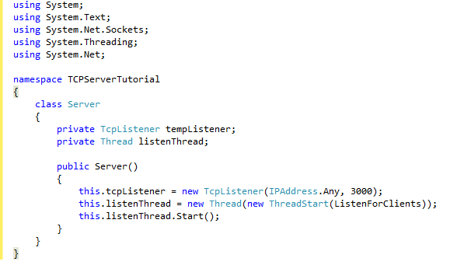

**Data**

The data centered software architecture is characterized by a centralized data store which is shared by all surrounding software component Here I show you connect data

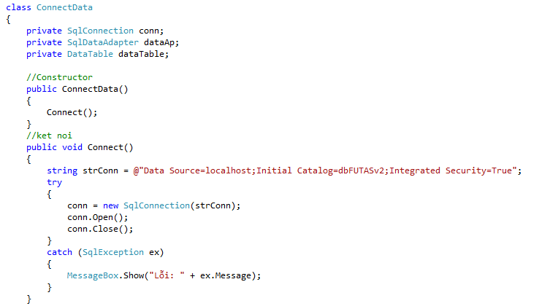

1. **Description of System Interface**

**Data flow**

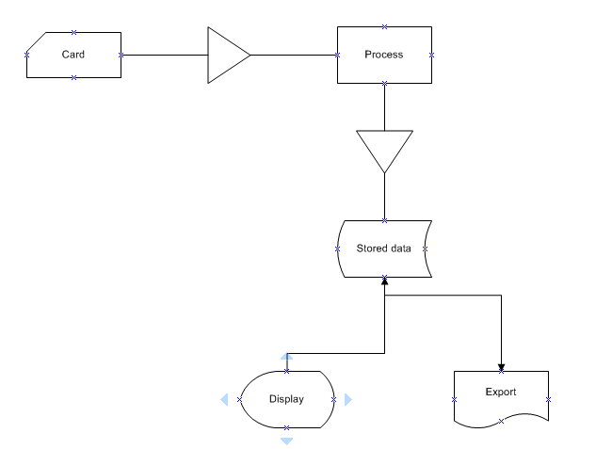

**Modules**

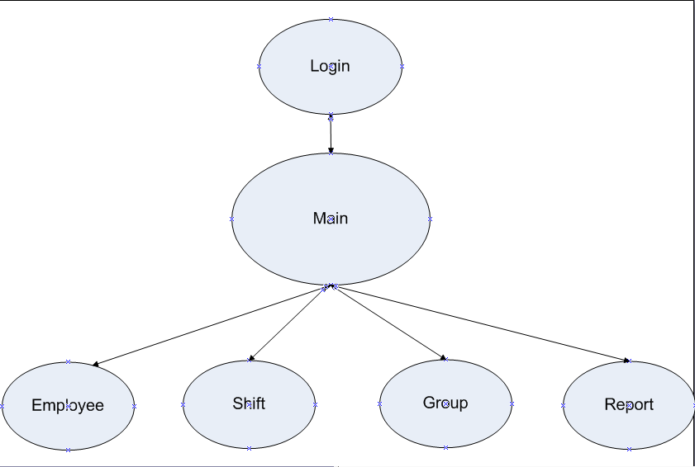

FUTAS include 4 main modules:

* Employee management
* Shift management
* Group management
* Report management

**Use Case Diagram**

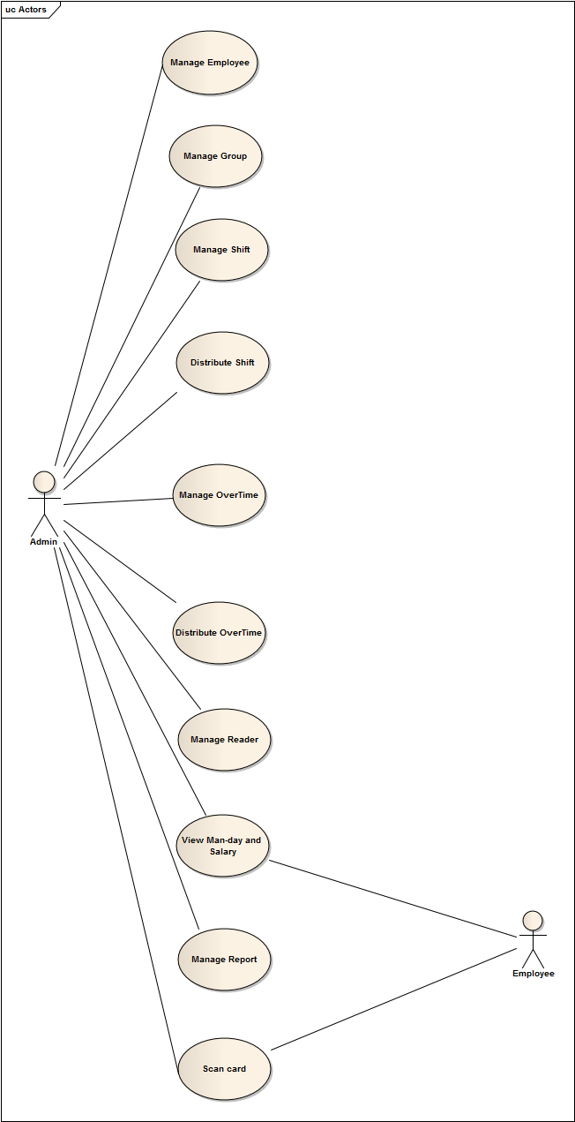

* FUTAS is used by only administrator Another employees want to view something must contact to administrator

**4.3 Class Diagram**

**3.1 Main form**

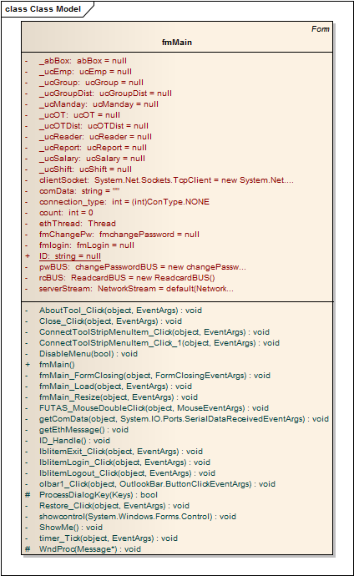

**3.2 Employee Management**

**3.2.1 Business Logic**

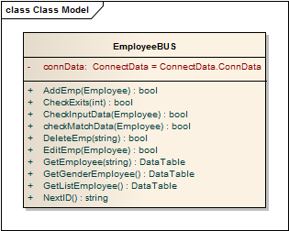

**3.2.2 Business Object**

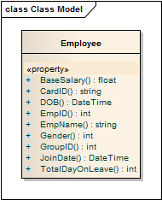

**3.2.3 Control**

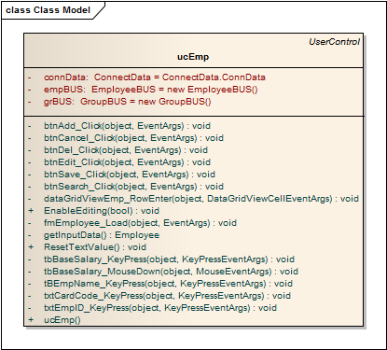

**3.3 Group Management**

**3.3.1 Business Logic**

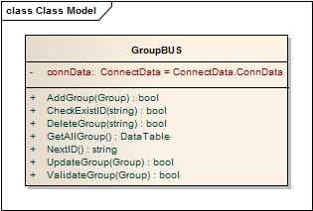

**3.3.2 Business object**

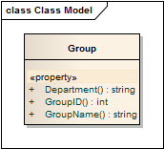

**3.3.3 Control**

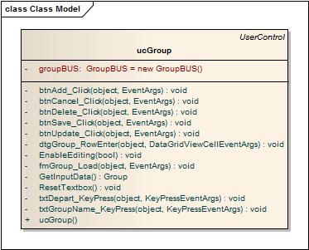

**3.4 Shift Management**

**3.4.1 Business Logic**

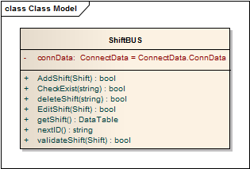

**3.4.2 Business Object**

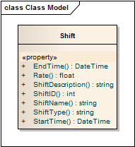

**3.3 Control**

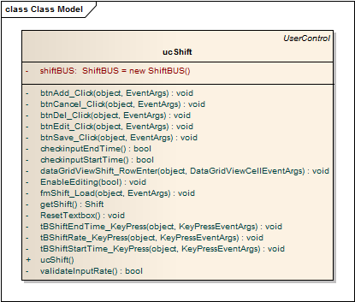

**3.5 Shift Distribution Management**

**3.5.1 Business Logic**

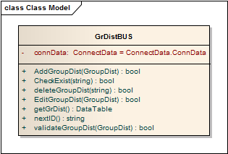

**3.5.2 Business Object**

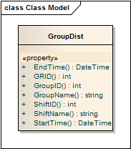

**3.5.3 Control**

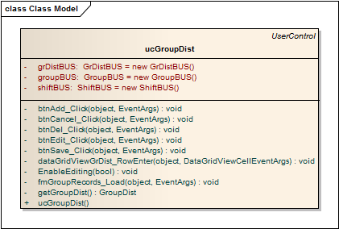

**3.6 overtime Management**

**3.6.1 Business Logic**

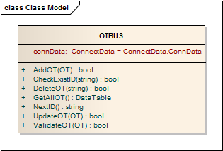

**3.6.2 Business Object**

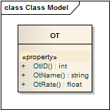

**3.6.3 Control**

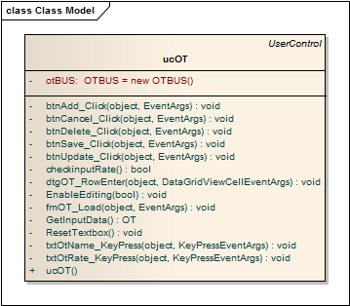

**3.7 overtime Distribution Management**

**3.7.1 Business Logic**

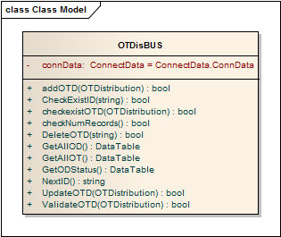

**3.7.2 Business Object**

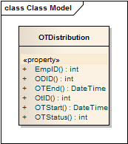

**3.7.3 Control**

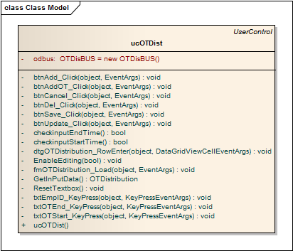

**3.8 Reader Management**

**3.8.1 Business Logic**

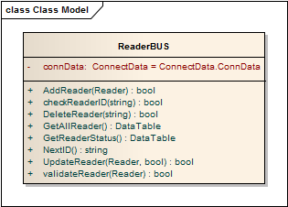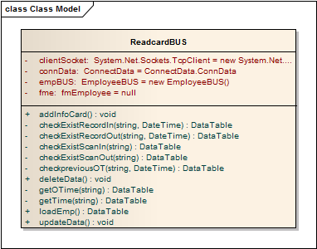

**3.8.2 Business Object**

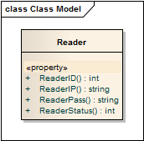

**3.8.3 Control**

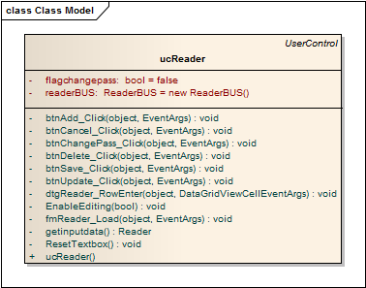

**3.9 View Man-day and Salary**

**3.9.1 Business Logic**

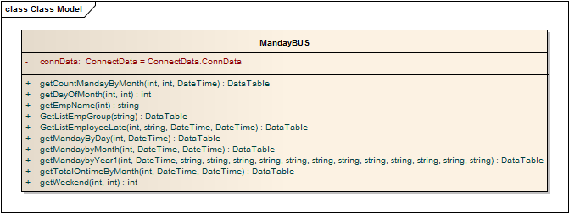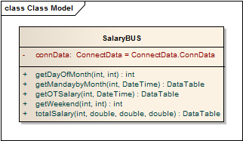

**3.9.2 Business Object**

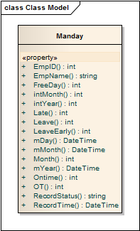

**3.9.3 Control**

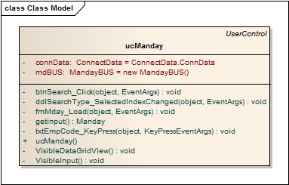

**3.10 Report Management**

**3.10.1 Control**

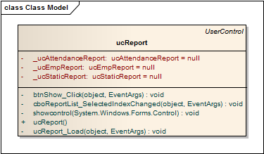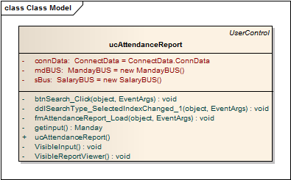

**3.11 Change Password**

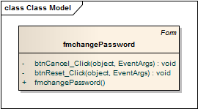

**4 Sequence Diagram**

**4.1 Employee Management**

Add new employee

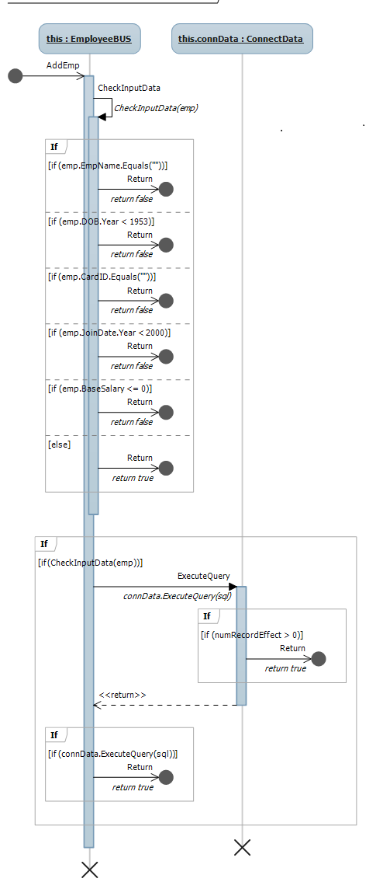

Edit employee

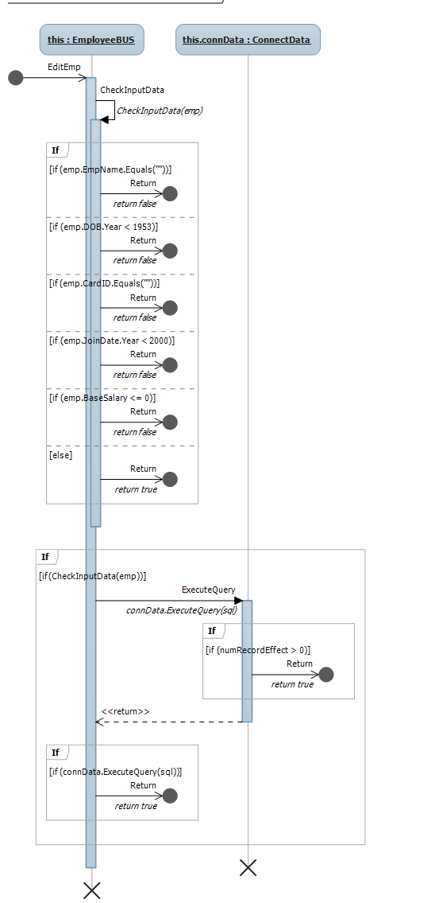

Delete employee

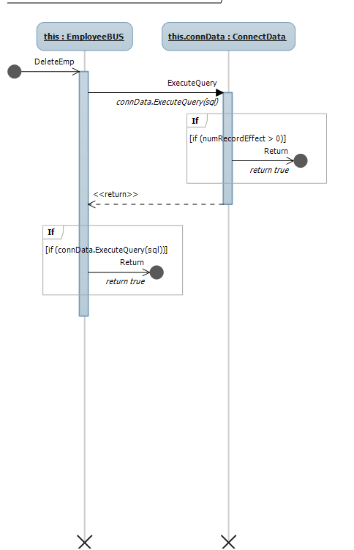

Get employee

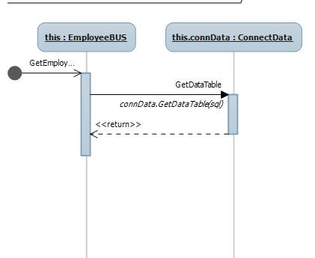

Check existed ID

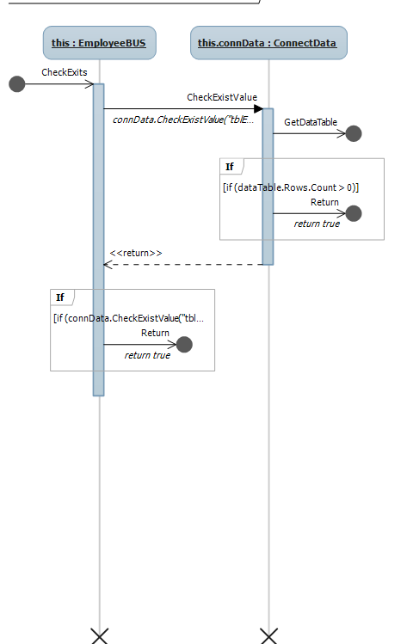

Next ID

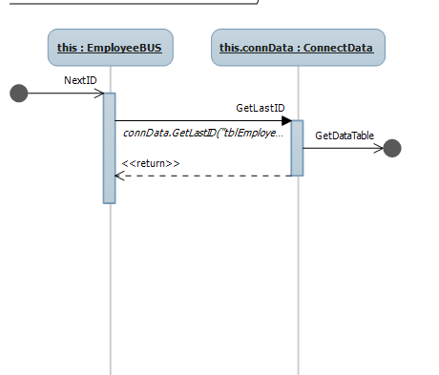

Validate employee information

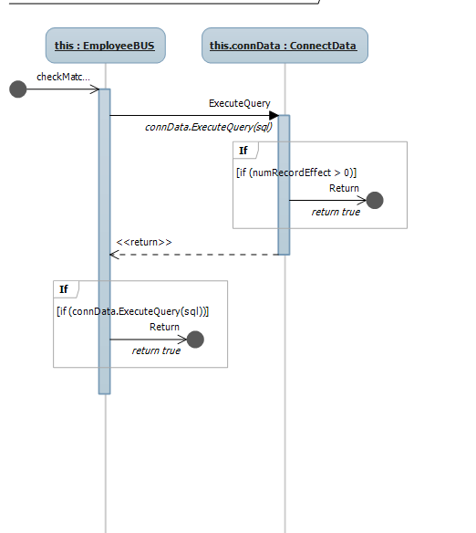

**4.2 Group Management**

Get group

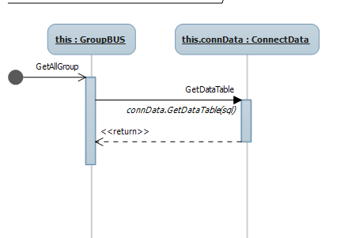

Add new employee

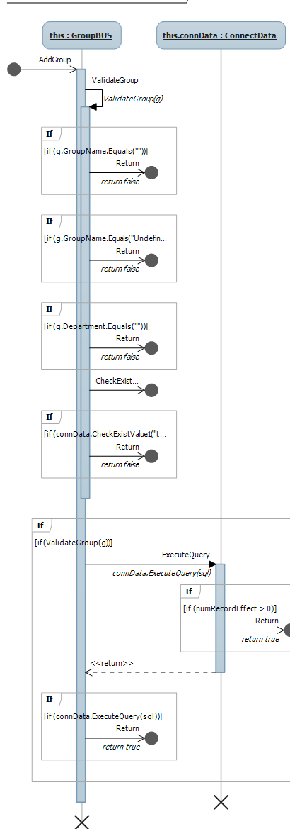

Update group information

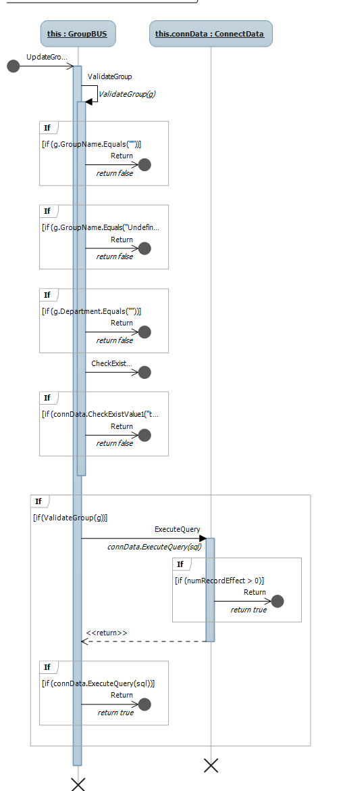

Delete group

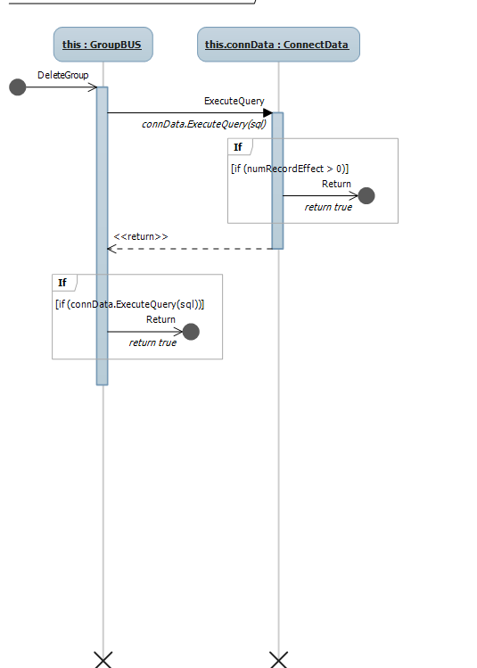

Check existed group

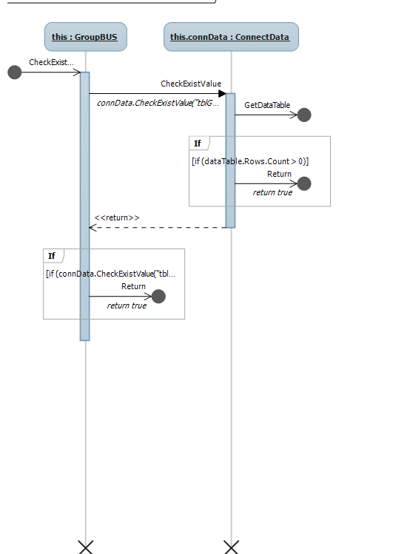

Validate group information

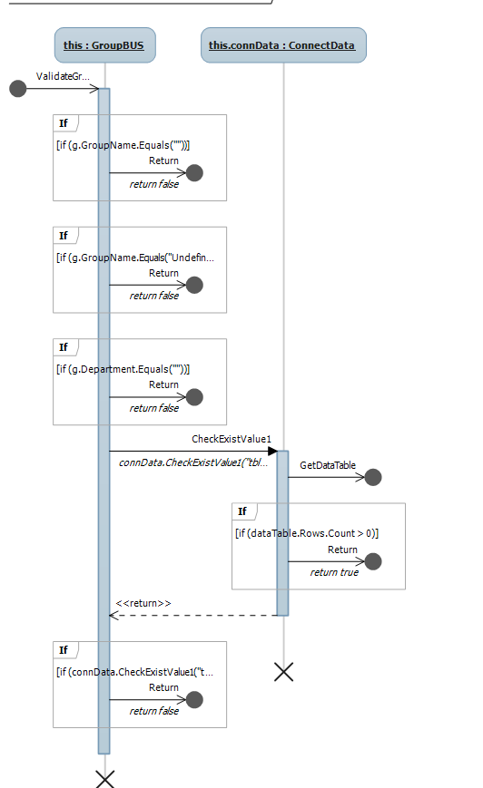

Next group ID

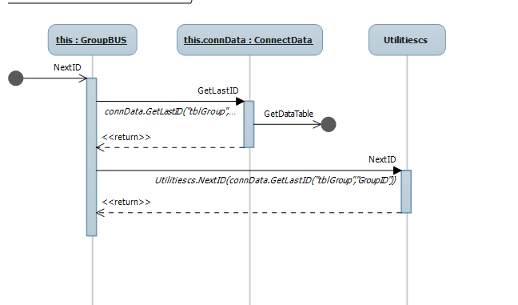

**4.3 Shift Management**

Get shift

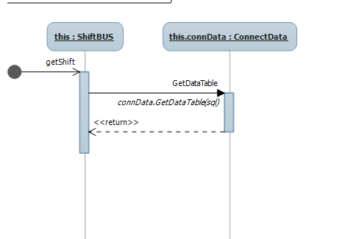

Add new shift

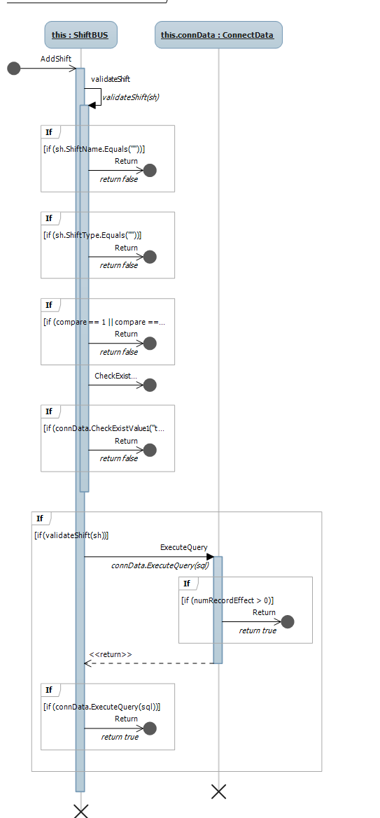

Edit shift

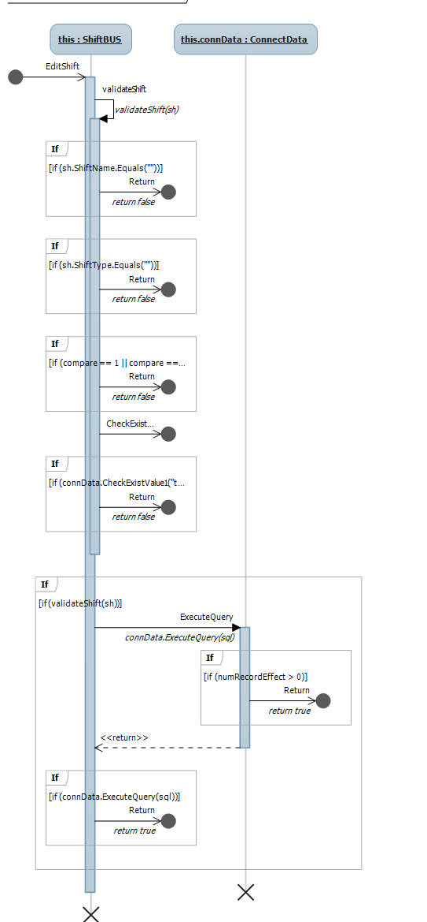

Delete shift

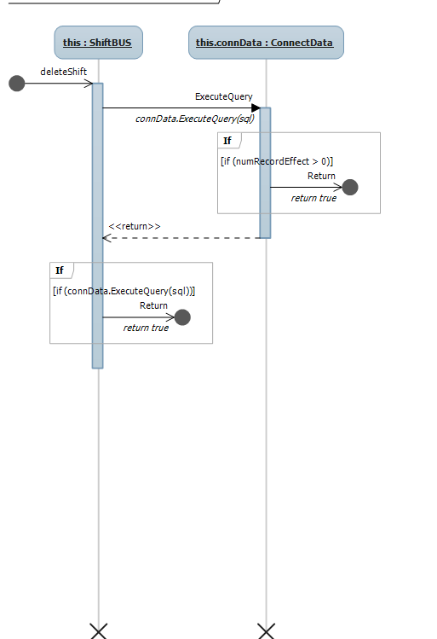

Validate shift

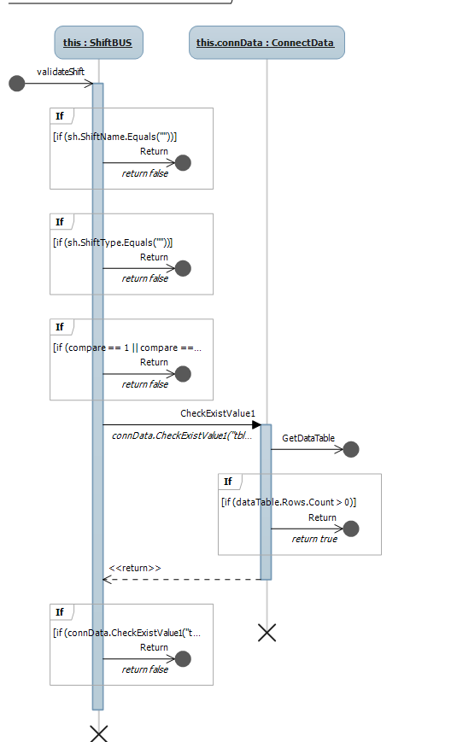

Check existed ID

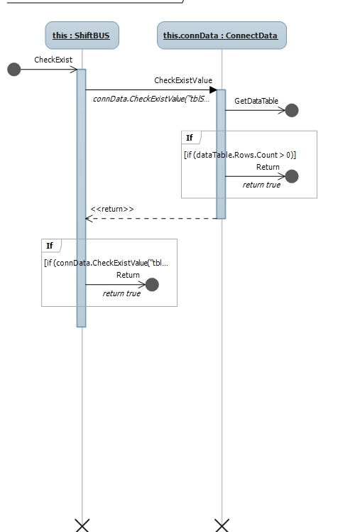

Next ID

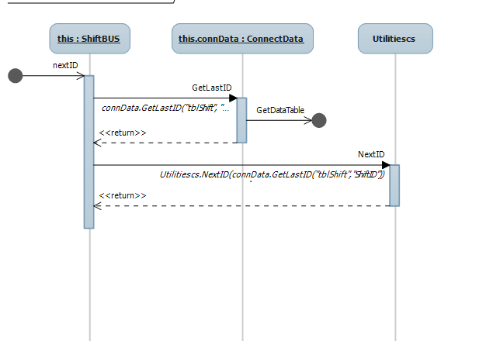

**4.4 Shift Distribution**

Add shift distribution

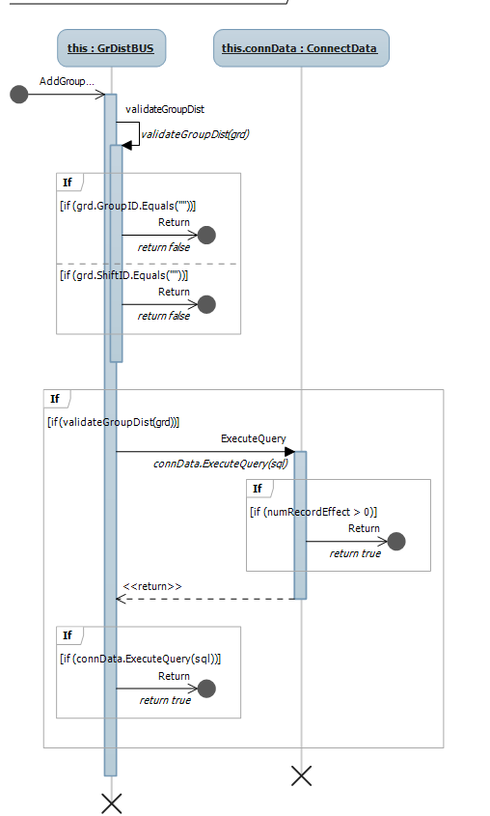

Edit shift distribution

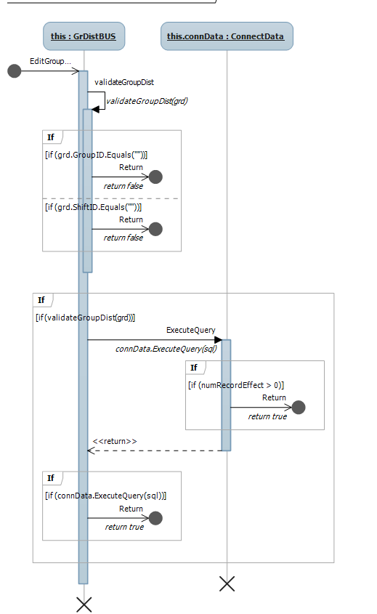

Delete shift distribution

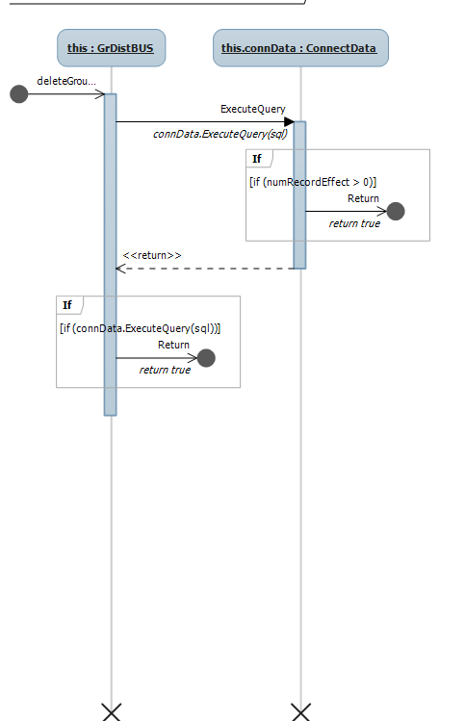

Get group distribution

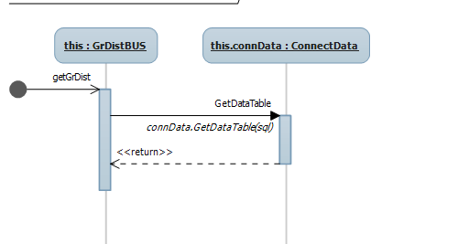

Check existed ID

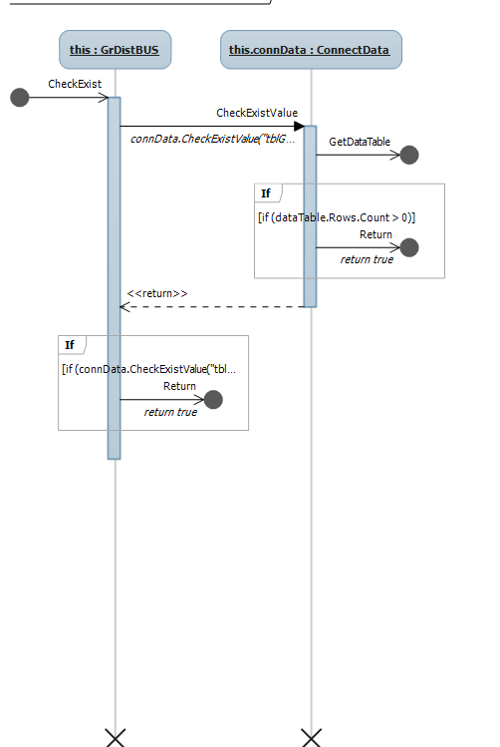

Validate shift information

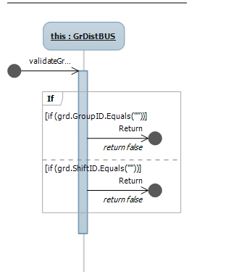

Next ID

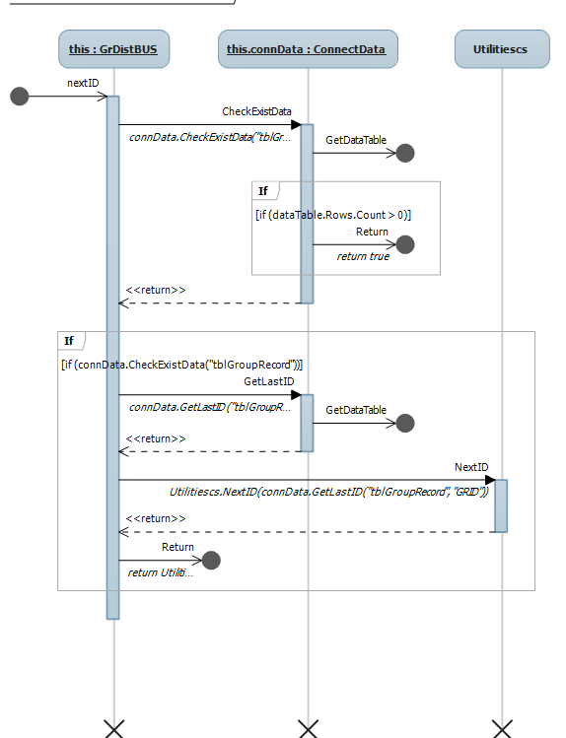

**4.5 overtime Management**

Add new overtime

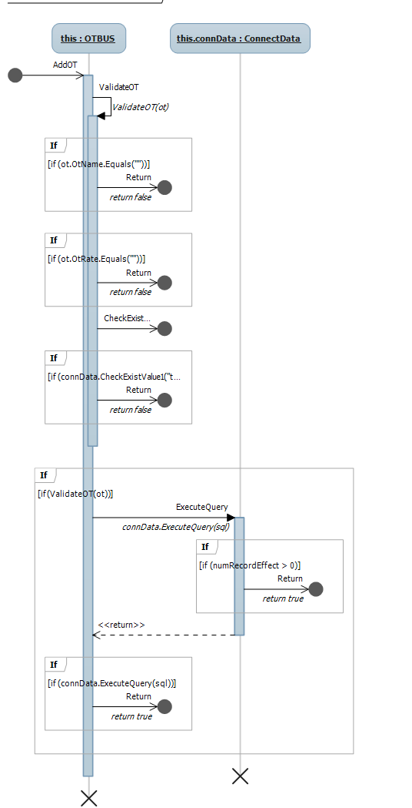

Delete overtime

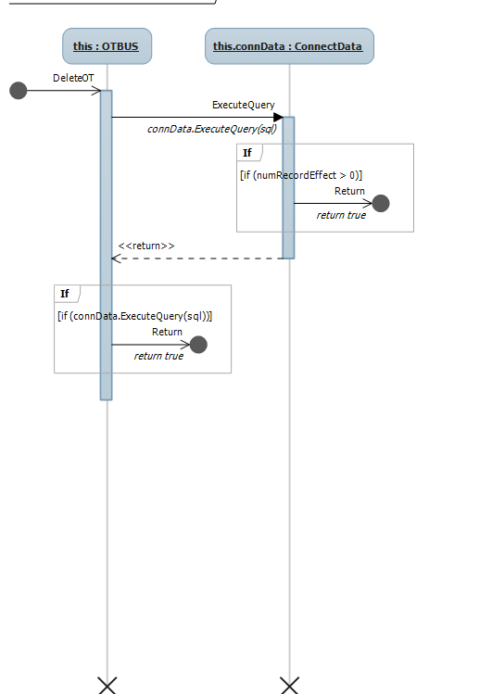

Get overtime

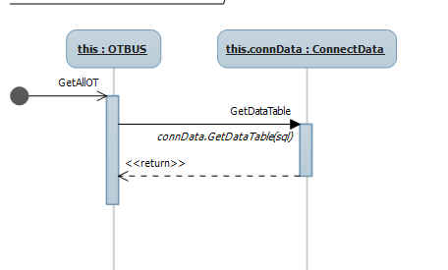

Edit overtime

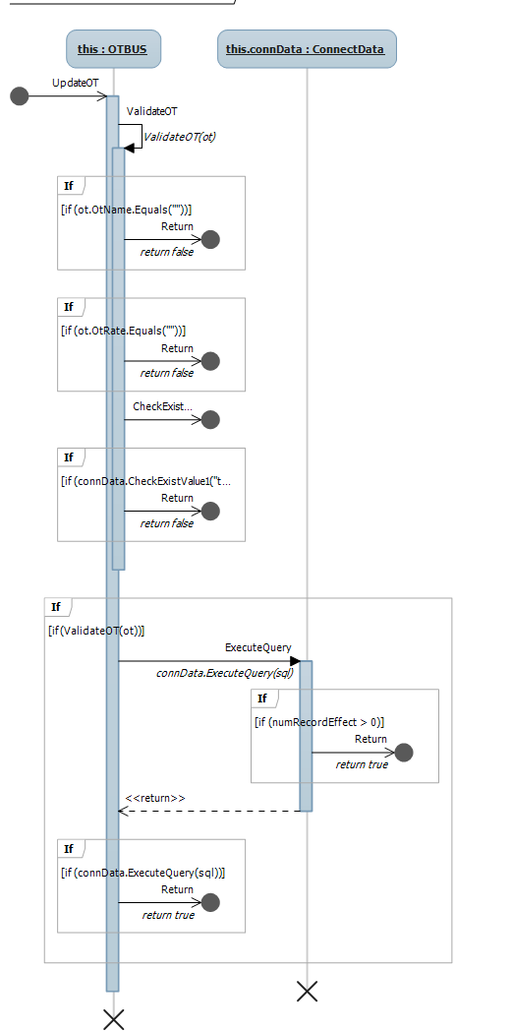

Check existed OT

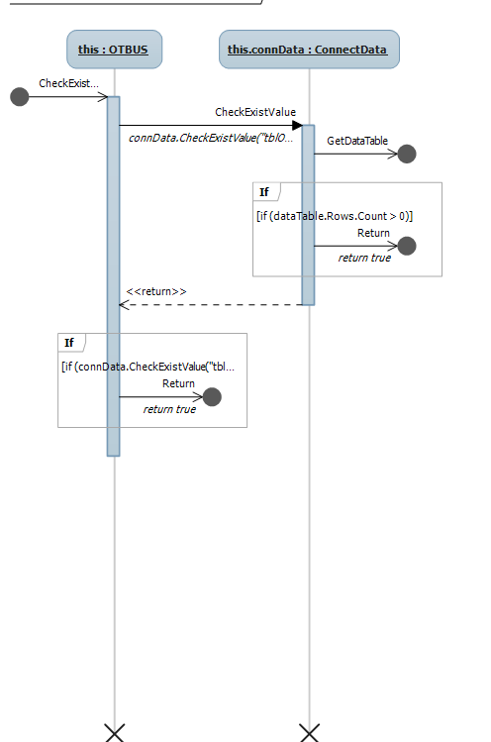

Next ID

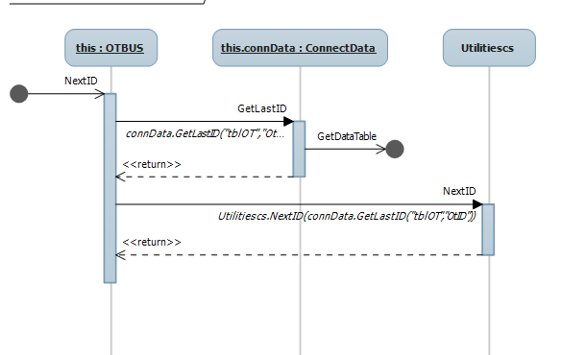

Validate overtime

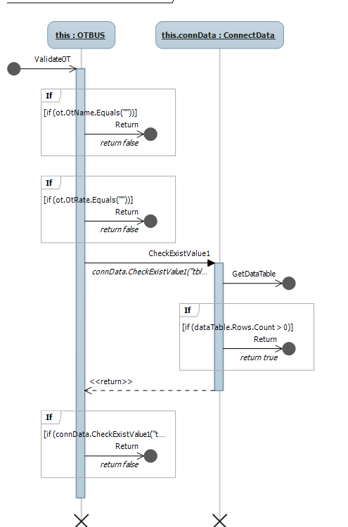

**4.6 overtime Distribution**

Add overtime distribution

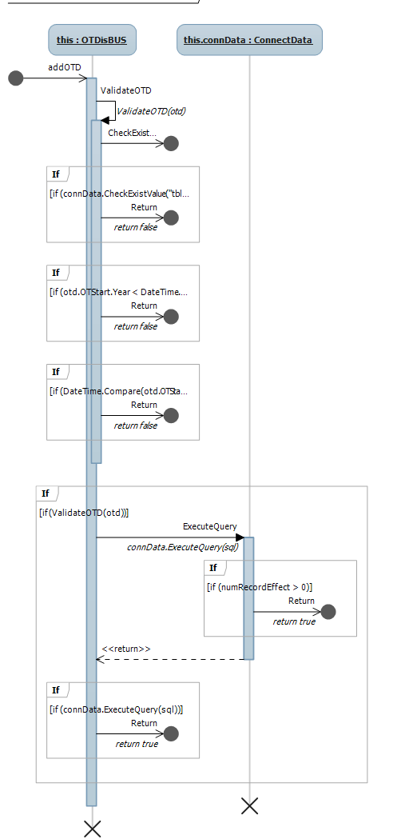

Edit overtime distribution

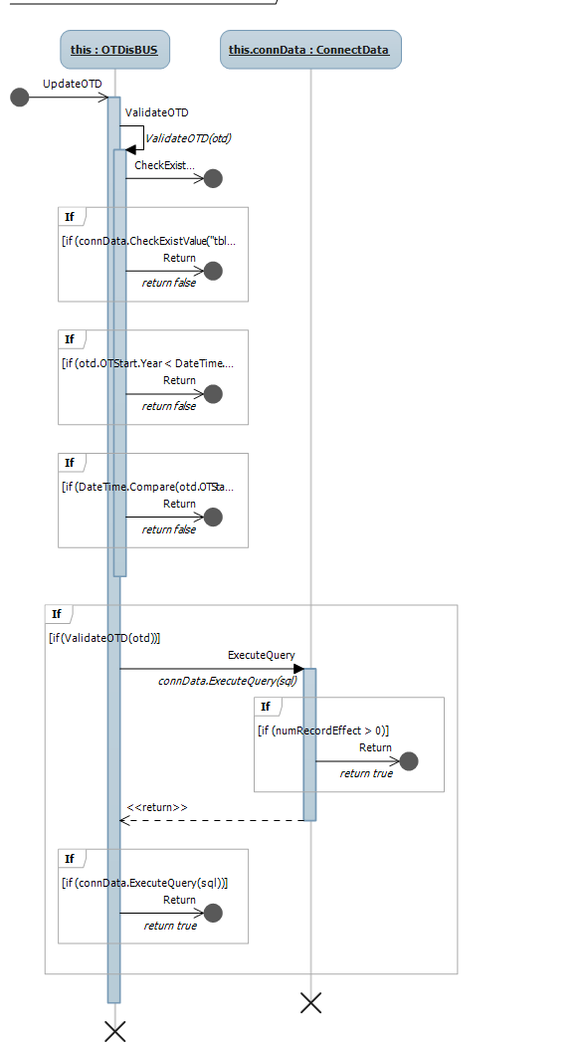

Delete overtime distribution

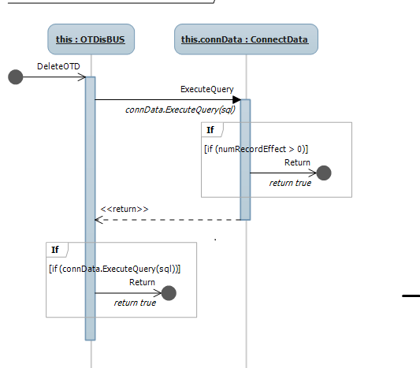

Get overtime distribution

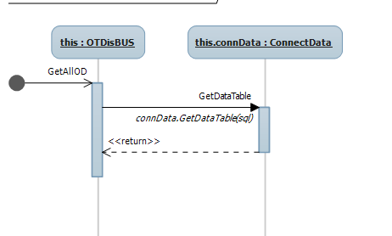

Check existed overtime distribution

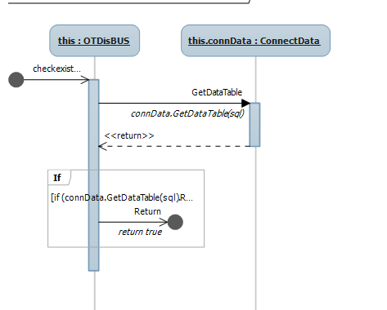

Check existed ID

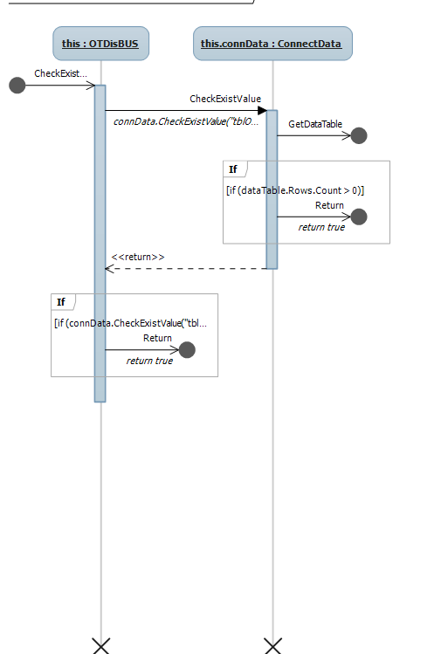

Next ID

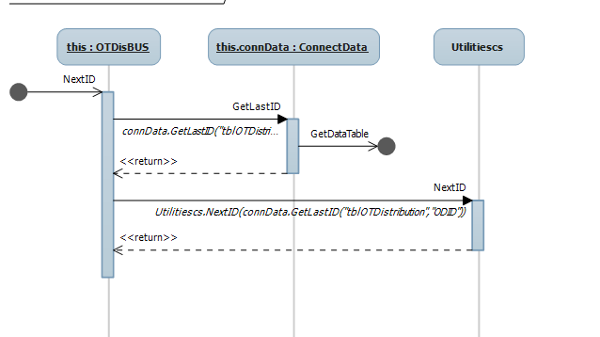

Validate overtime distribution

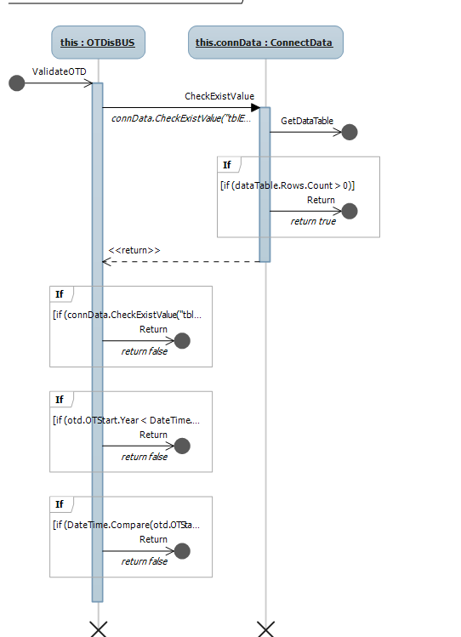

**4.7 Man-day**

Get employee name

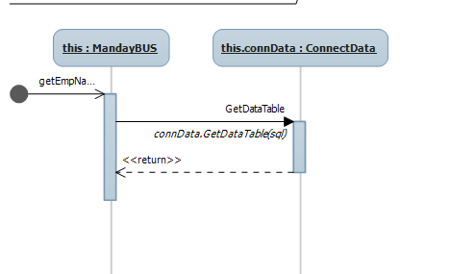

Get list employee by group

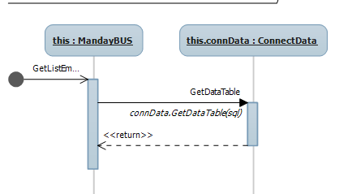

Get late

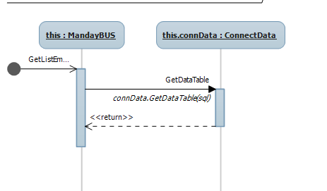

Get man-day

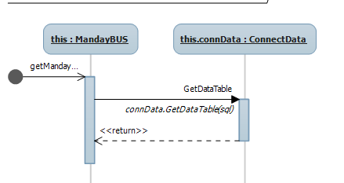

**4.8 Salary**

Calculate overtime salary

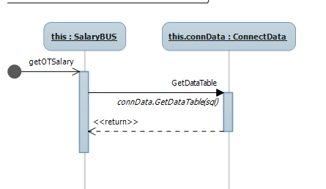

Calculate total salary

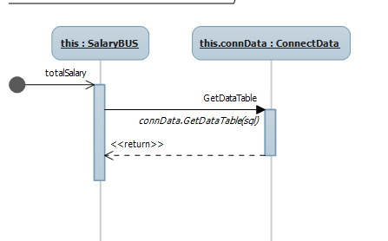

**4.9 Main menu**

Load form

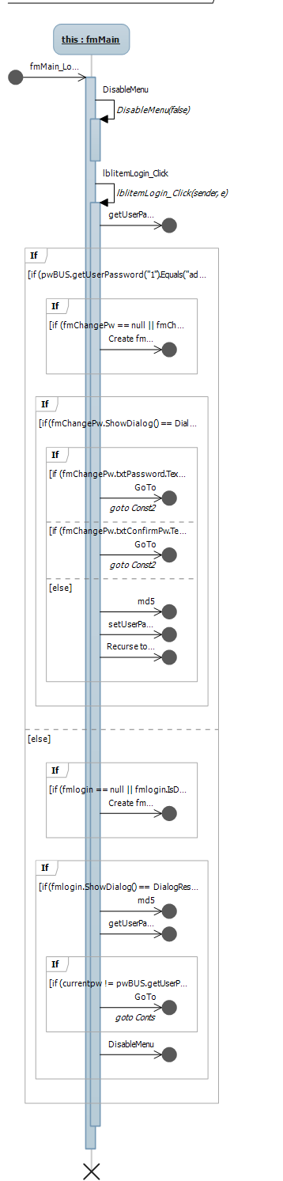

Process dialog key

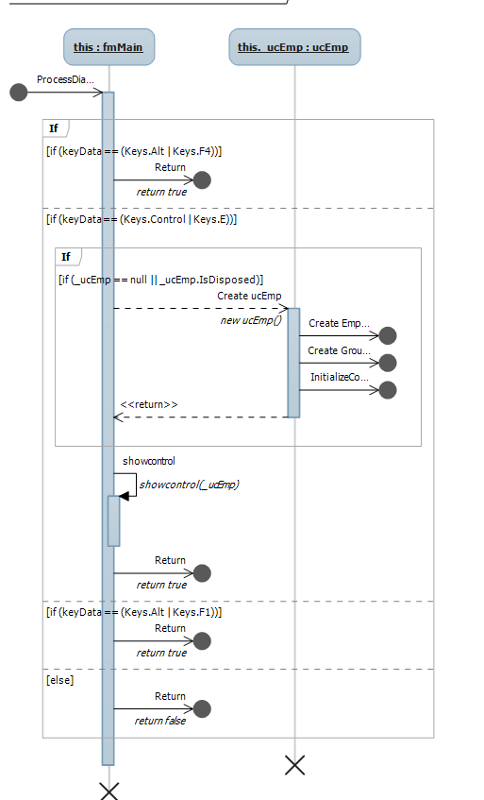

Get computer data

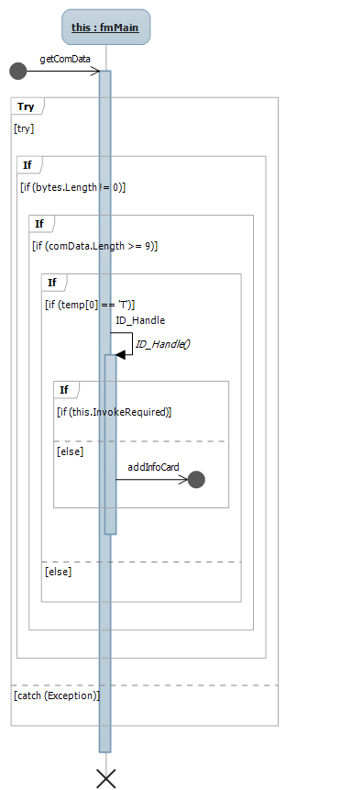

Get message

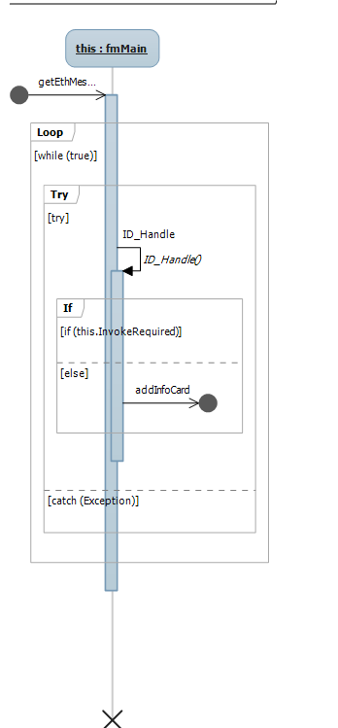

Tool click

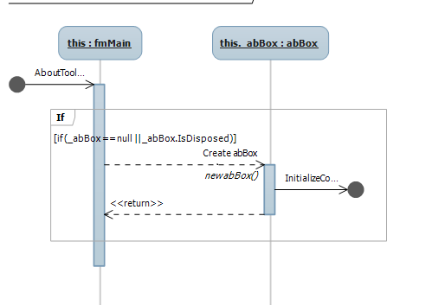

Tool strip

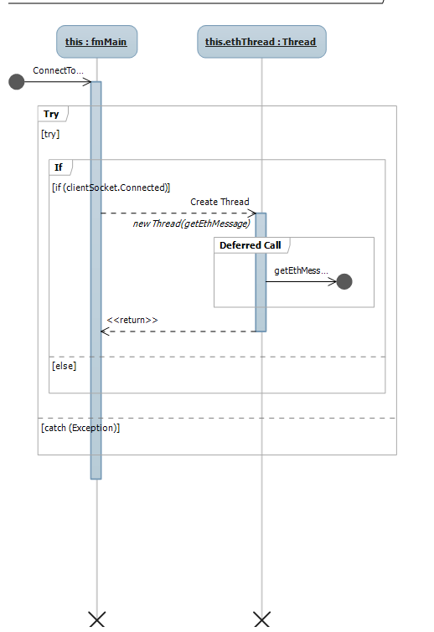

**4.10 Connect data**

Check existed data

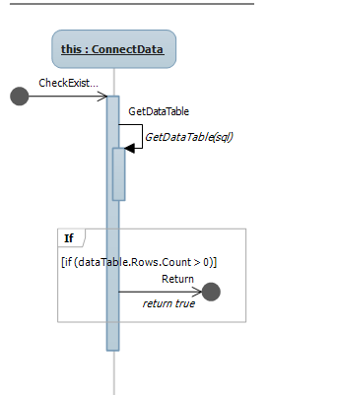

Check existed value

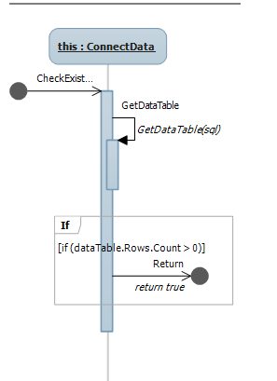

Check count table

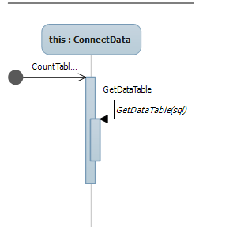

**4.11 Read card**

Add card information



Check existed card

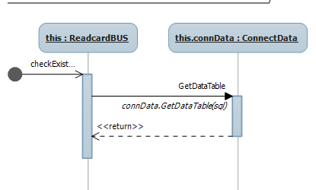

Delete data

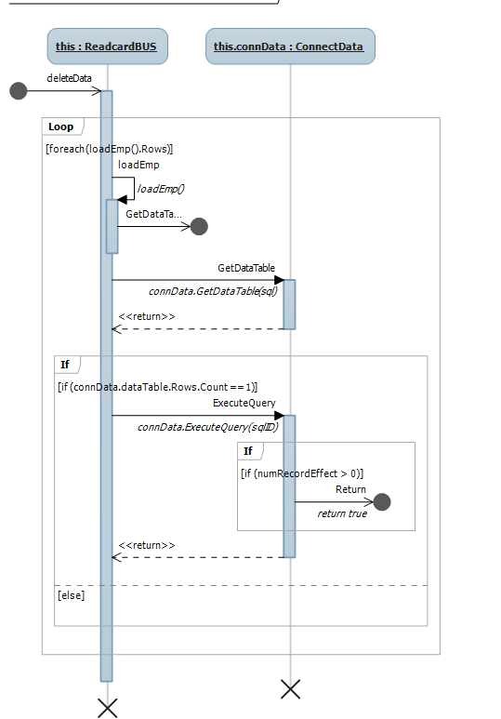

Update data

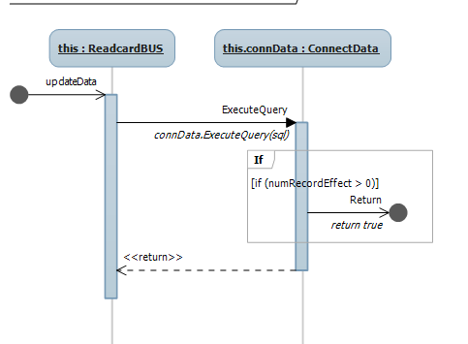

Get time

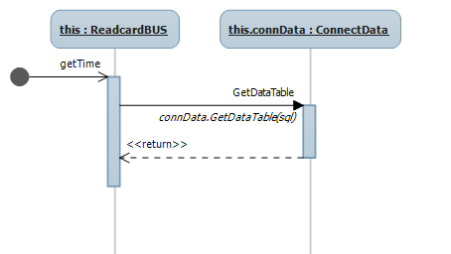

**4.12 Change password**

Get user password

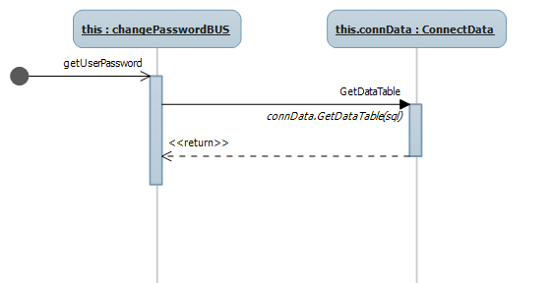

Set user password

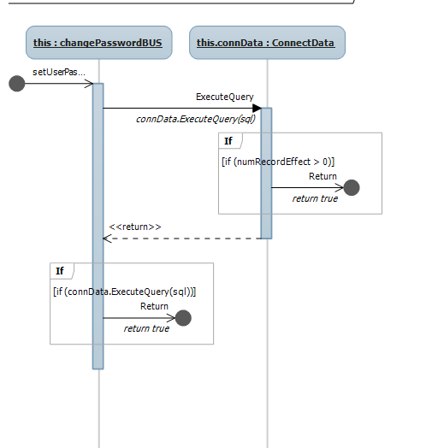

**4.13 Report Management**

Attendance report

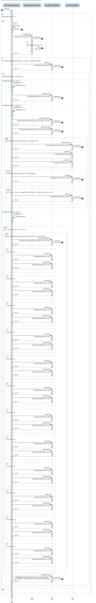

Employee report

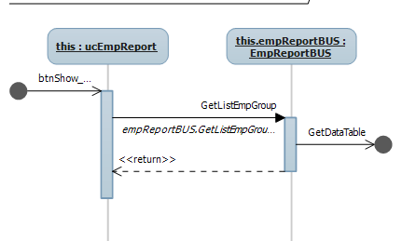

Static report

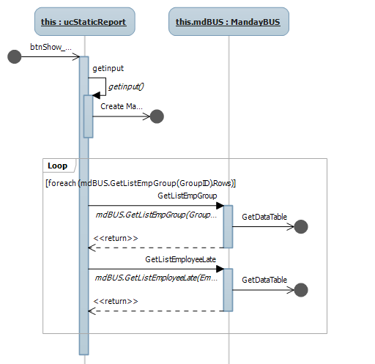

**5. User interface design**

1. **Login**

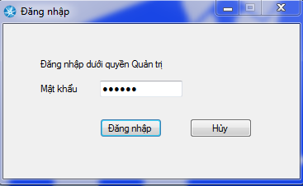

* System login only by administrator
* Password is encoded, one times change

1. **Main menu**

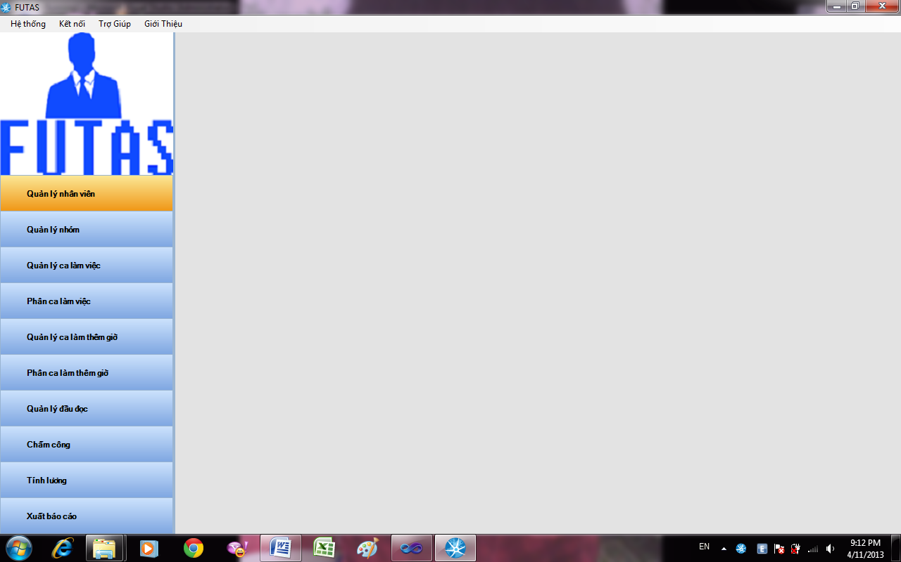

|  |  |
| --- | --- |
| Quản lý nhân viên | Link to employee management form |
| Quản lý nhóm | Link to group management form |
| Quản lý ca làm việc | Link to shift management form |
| Quản lý ca làm thêm giờ | Link to overtime management form |
| Chấm công và tính lương | Link to man-day & salary management |
| Xuất báo cáo | Link to report management |
| Quản lý nhóm | Link to group management form |
| Phân ca làm việc | Link to shift distribution form |
| Phân ca làm thêm giờ | Link to overtime distribution form |

1. **Employee Management**

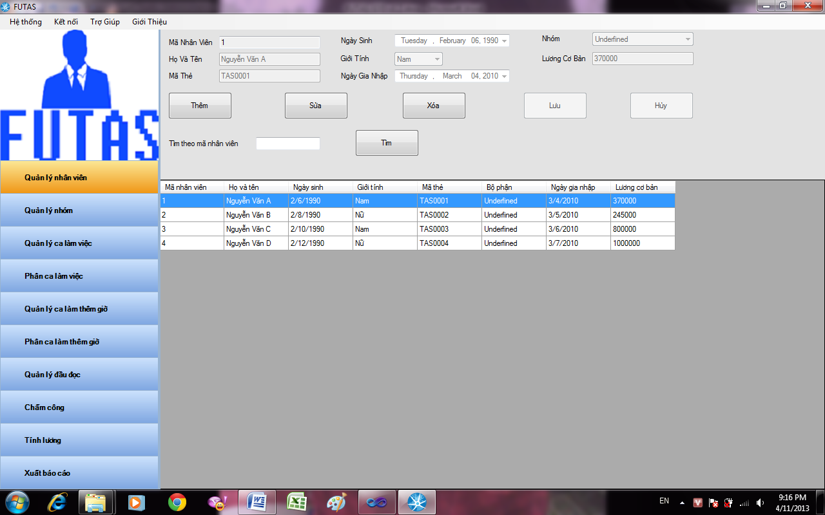

|  |  |
| --- | --- |
| Mã Nhân Viên | ID of an employee(automatically increase) |
| Họ Và Tên | Enter full name of an employee to textbox |
| Mã Thẻ | Enter code of a card to textbox |
| Ngày sinh | Select birthday of employee above |
| Giới tính | Select gender of employee above |
| Ngày gia nhập | Select join date of employee above |
| Bộ phận | Select group employee will join |
| Lương cơ bản | Enter base salary of employee above |
| Thêm | Click button add to add new employee to database |
| Sửa | Click button edit to edit employee selected in database |
| Xóa | Click button delete to remove employee selected in database |
| Lưu | Click button save to save employee edited in database |
| Hủy | Click button cancel to cancel activity |
| Tìm kiếm theo mã nhân viên | Enter ID employee name to textbox |
| Tìm kiếm | Click button to search employee information |

1. **Group Management**

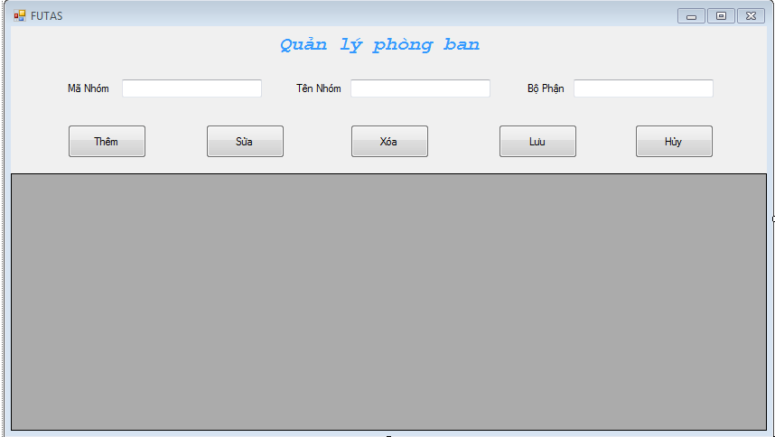

|  |  |
| --- | --- |
| Mã Nhóm | ID of group (automatically increase) |
| Tên Nhóm | Enter name of group in textbox |
| Bộ Phận | Enter department of group in textbox |
| Thêm | Click add button to add new group to database |
| Sửa | Click edit button to edit group selected to database |
| Xóa | Click delete button to delete group selected in database |
| Lưu | Click save button to save group edited in database |
| Hủy | Click cancel button to cancel activity |

1. **Shift Management**

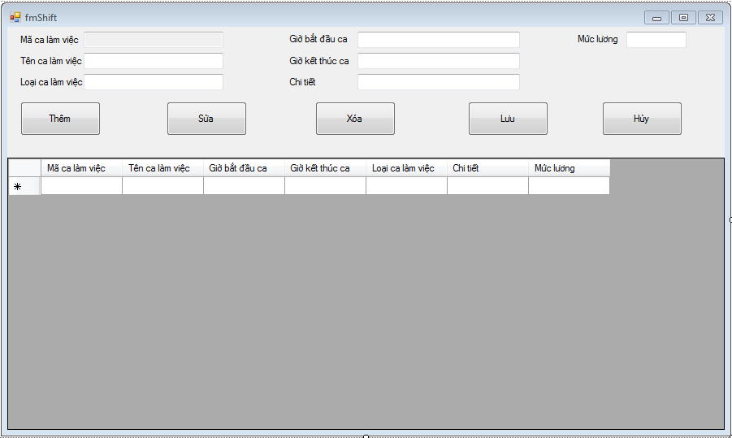

|  |  |
| --- | --- |
| Mã ca làm việc | ID of a shift (automatically increase) |
| Tên ca làm việc | Enter name of shift in textbox |
| Loại ca làm việc | Enter type of shift in textbox |
| Giờ bắt đầu ca | Enter time start of shift above in textbox |
| Giờ kết thúc ca | Enter time end of shift above in textbox |
| Chi tiết | Enter detail of shift above in textbox |
| Mức lương | Enter salary level of shift above in textbox |
| Thêm | Click add button to add new shift to database |
| Sửa | Click edit button to edit selected shift in database |
| Xóa | Click delete button to delete selected shift in database |
| Lưu | Click save button to save edited shift in database |
| Hủy | Click cancel button to cancel activity |

1. **Shift distribution**

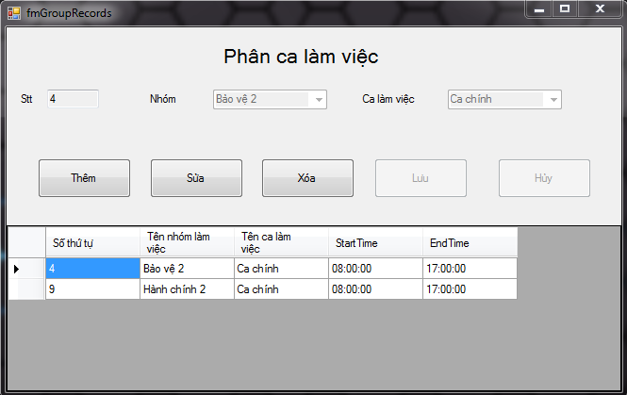

Figure 4.19 Shift Distribution Management Screen

|  |  |
| --- | --- |
| Stt | List |
| Nhóm | Select group |
| Ca làm việc | Select shift |
| Thêm | Click add button to distribute group to a shift |
| Sửa | Click edit button to edit selected group in a shift |
| Xóa | Click delete button to remove selected group in a shift |
| Lưu | Click save button to save edited group in a shift |
| Hủy | Click cancel button to cancel activity |

1. **Overtime Management**

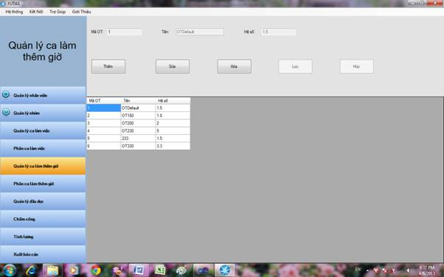

|  |  |
| --- | --- |
| Mã OT | ID of an overtime shift(automatically increase) |
| Hệ số | Multiplier factor |
| Tên | Name of an overtime shift |
| Thêm | Click add button to add overtime shift to database |
| Sửa | Click edit button to edit selected overtime shift in database |
| Xóa | Click delete button to delete selected overtime shift in database |
| Lưu | Click save button to save edited overtime shift in database |
| Hủy | Click cancel button to cancel activity |

1. **Overtime distribution**

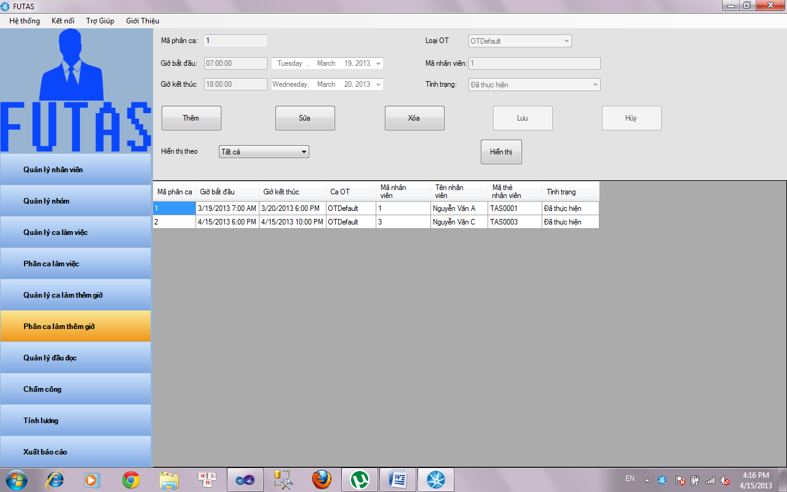

|  |  |
| --- | --- |
| Mã phân ca | ID of an overtime shift |
| Loại OT | Select type of an overtime shift |
| Ngày kết thúc | Enter time end of an overtime shift |
| Ngày bắt đầu | Enter time start of an overtime shift |
| Ngày OT | Select day registered of an overtime shift |
| Mã nhân viên | Enter ID of an employee |
| Tình trạng | State of an overtime shift |
| Hiển thị theo | Select type of overtime display |
| Hiển thị theo | Click display button to show overtime |
| Thêm | Click add button to distribute employee in an overtime shift |
| Sửa | Click edit button to edit distributed employee in an overtime shift |
| Xóa | Click delete button to delete distributed employee in an overtime shift |
| Lưu | Click save button to save edited employee in an overtime shift |
| Hủy | Click cancel button to cancel activity |

1. **Readers Management**

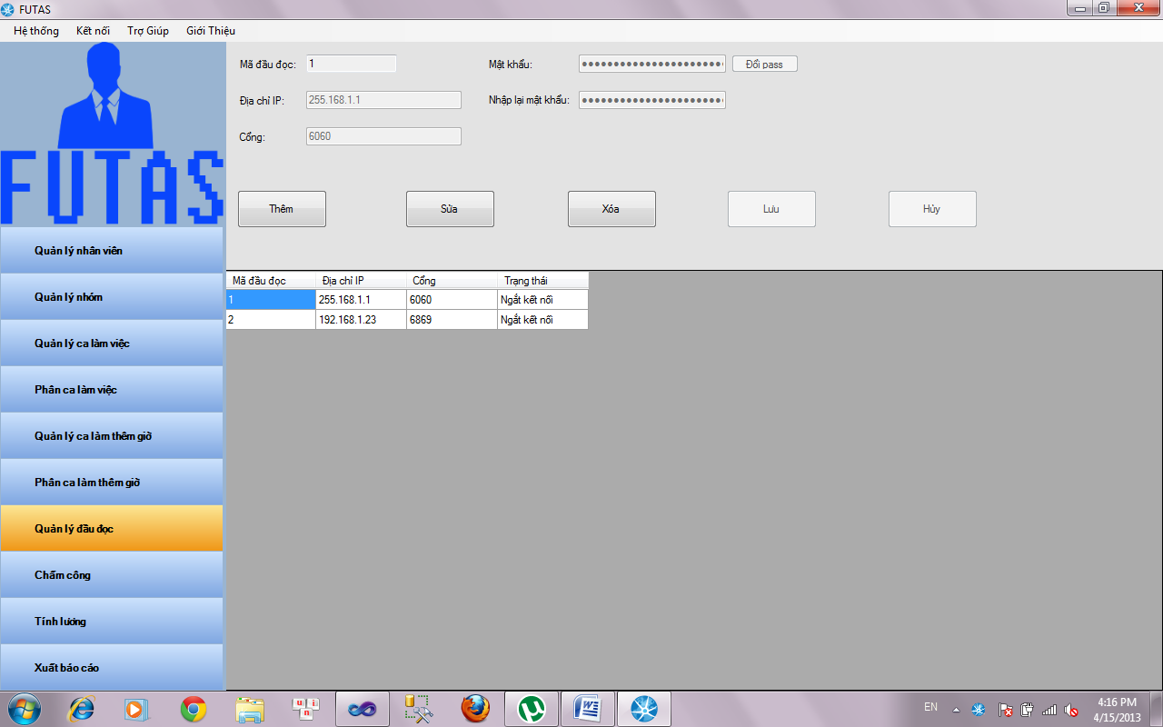

|  |  |
| --- | --- |
| Mã đầu đọc | ID of a reader |
| Mật khẩu | Password of a reader |
| Đổi mật khẩu | Click button change pass to change password of a reader |
| Địa chỉ IP | IP address of a reader |
| Nhập lại mật khẩu | Confirm password was type above |
| Cổng | Enter port of reader |
| Thêm | Click button add to add reader to database |
| Sửa | Click button edit to edit selected reader in database |
| Xóa | Click button delete to delete selected reader in database |
| Lưu | Click button save to save edited reader in database |
| Hủy | Click button cancel to cancel activity |

1. **Man-day and Salary**

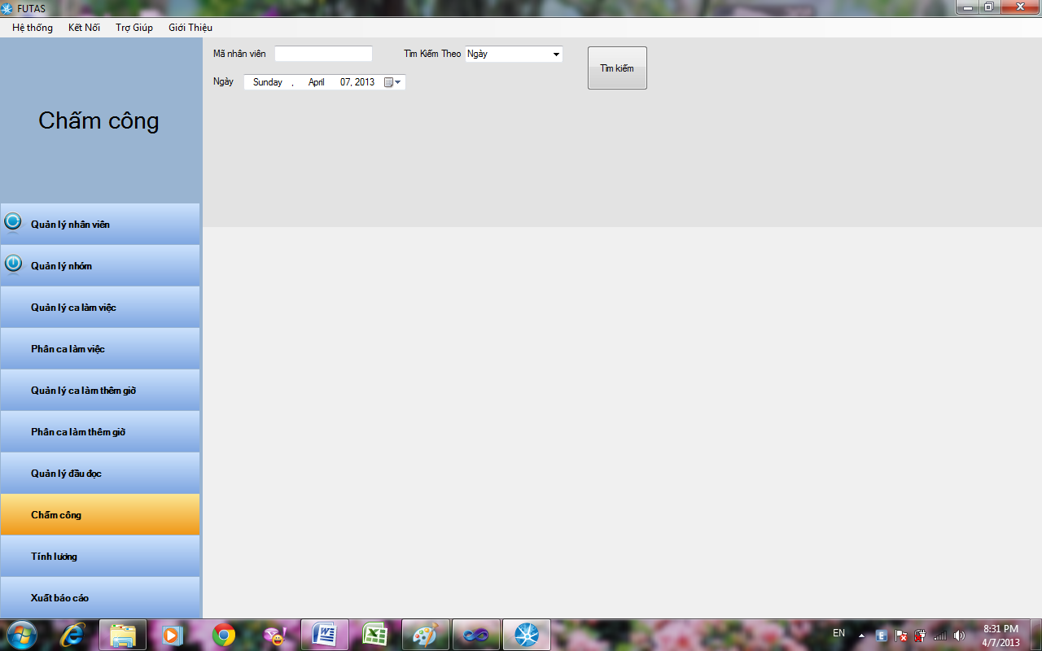

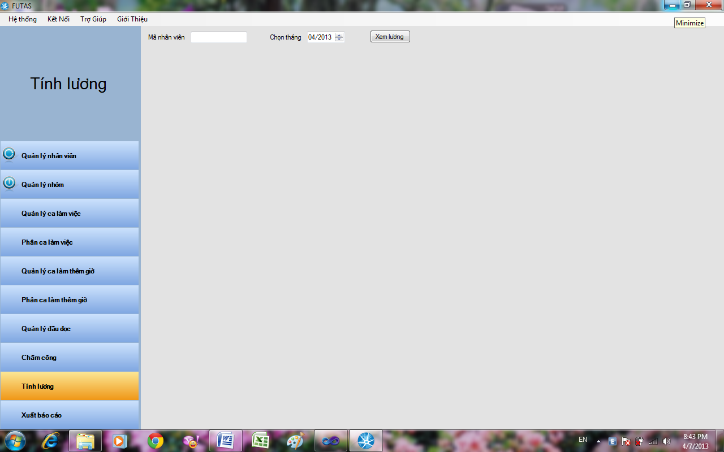

1. **Report Management**

Select report screen

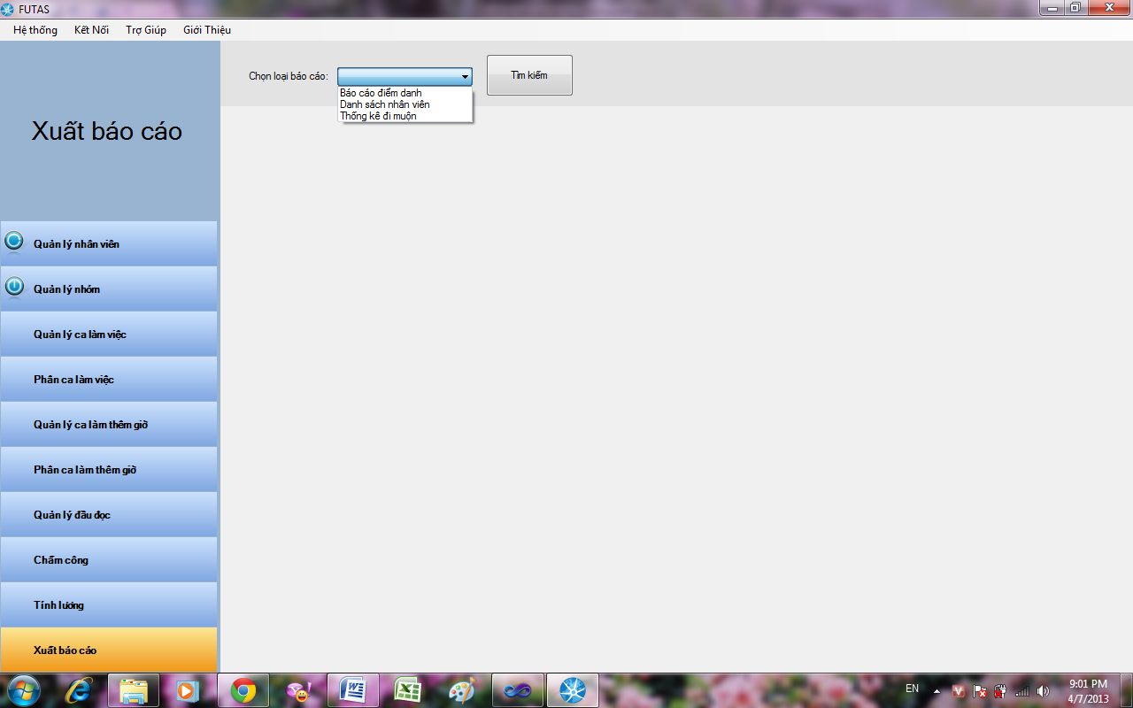

Attendance report

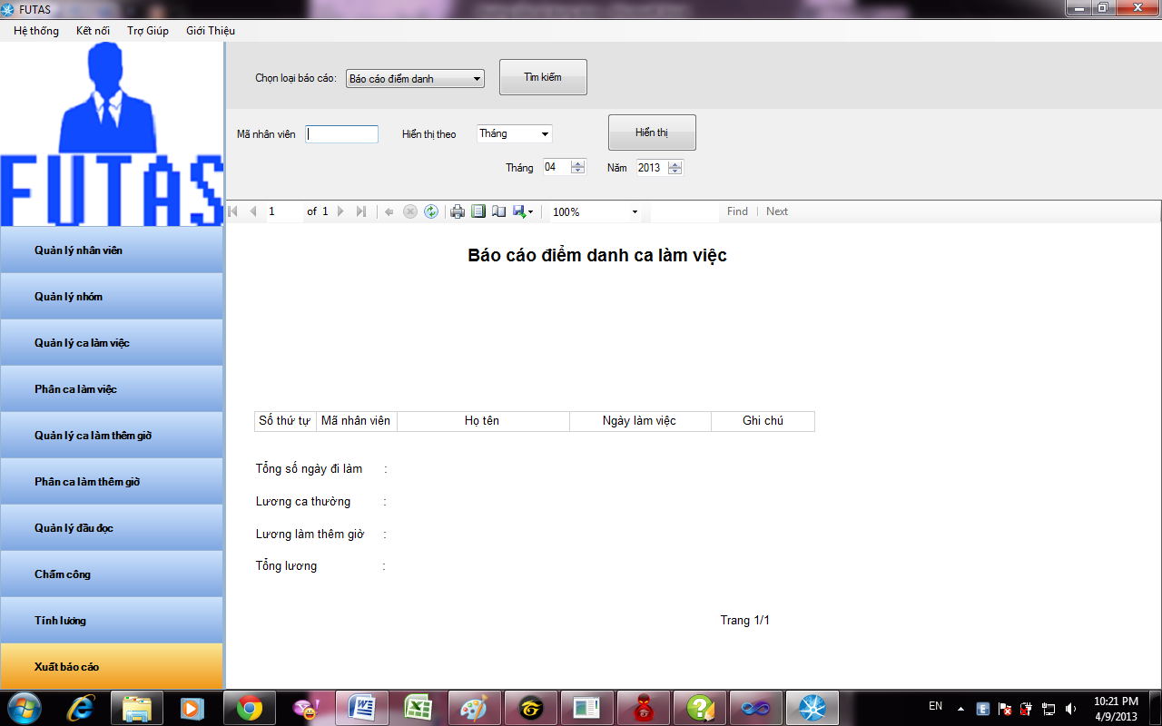

List report

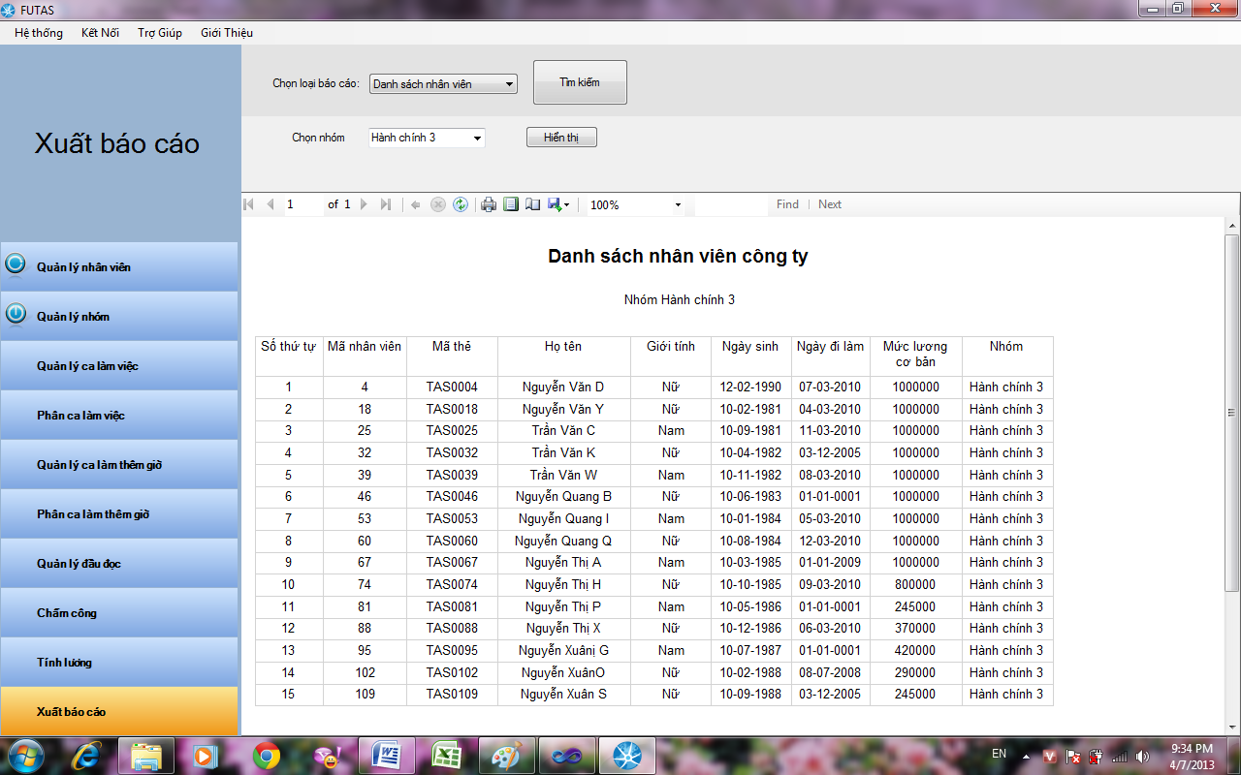

Static report

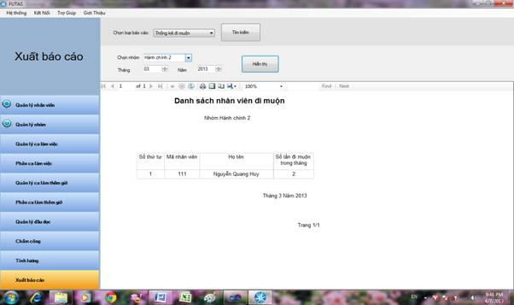

1. **Database design**

**a. Table detail**

* Employee
  + ID(Primary key)
  + NAME
  + DOB
  + JOINT DATE
  + GROUP ID
  + CARD ID
  + DAY ON LEAVE
  + TOTAL DAY ON LEAVE
  + BASE SALARY
  + GENDER
* GROUP
  + GROUP ID(Primary key)
  + NAME
  + DEPARTMENT
* SHIFT
  + SHIFT ID(Primary key)
  + NAME
  + TIME START
  + TIME END
  + SHIFT TYPE
  + RATE
  + DESCRIPTION
* Group Record
  + ID(Primary key)
  + GID
  + Shift ID
* RECORD
  + ID(Primary key)
  + EMPLOYEE ID
  + READER ID
  + CARD ID
  + TIME
  + STATUS (ONTIME/ LATE)
* READER
  + CARD READER ID(Primary key)
  + USER
  + PASS
  + IP
* OVERTIME
* OVERTIME ID(Primary key)
* NAME
* RATE
* OVERTIME DISTRIBUTION
* OVERTIME DISTRIBUTION ID(Primary key)
* START TIME
* END TIME
* EMPLOYEE ID
* OVERTIME ID

**b. Design diagram of database**

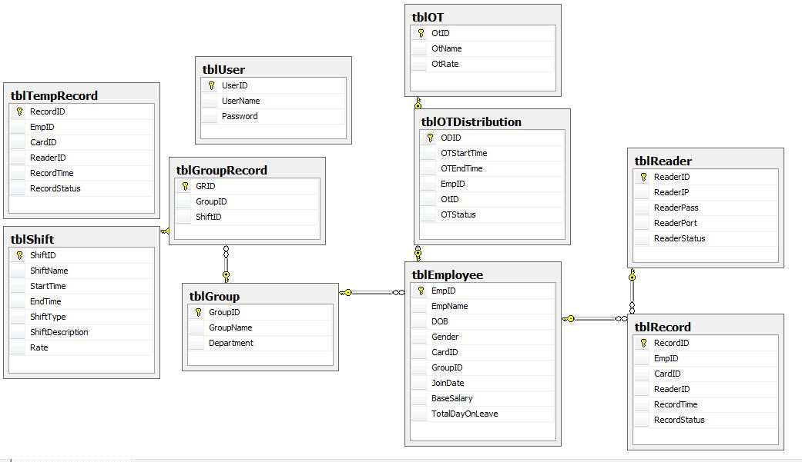

**V. System Testing**

1. System Introduction

**a. System overview**

**Definition**: Time and attendance systems make tracking and organizing the work hours of employees simple and straightforward. Indeed, these ‘clocking-in’ system can provide companies with the twin benefits of reducing their administration process and inspiring greater employee confidence in the accuracy of their salaries. In addition to theses benefits, investing in an attendance recording system can also help to streamline a business by indirectly increasing productivity and decreasing cost

**How it works**: Employees use a time and attendance system to clock-in and out of work whenever they start or finish a shift. This is done by swiping a unique ID which may come in the form of a barcode, magnetic stripe or pin code through a time recording device (a heading reader). Proximity cards can also be used, as these allow employees to clock-in or out by waving the card near the reader instead of swiping it through

**Type of system**: the type of attendance recording system a company chooses to purchase will depend largely upon the requirements of their own particular business. Fortunately, there are many different solutions available to suit all needs and circumstances. As well as traditional stand-alone time recorders, there are also more comprehensive solutions available which are fully compatible with HR (Human Resource), payroll and access control system. Indeed, sometime recording systems can cater for personal schedules, such as overtime, holidays and sick days, as well as gauge instances of lateness or absence. Even more complex system can allow companies to carry out management activities such as worker scheduling, productivity, estimating and labor forecasting. In fact, there are some systems that can even provide detailed information regarding individual work tasks or projects performed each day.

**b. Test approach**

Use top down testing (**Top Down Testing** is an approach to integrated testing where the top integrated modules are tested and the branch of the module is tested step by step until the end of the related module)

**2. Test plan**

**a. Features to be tested**

* Functional & non-functional
* GUI
* Hardware
* Modules combination

**b. Features not to be tested**

* Installation
* Security

**c. Testing tool and environment**

* Microsoft .net 4.0
* Microsoft visual studio 2010
* Microsoft SQL server 2008
* Microsoft window XP, Window 7, Window server

**3. Test Cases**

**Refer file**

* **FUTAS-TestCaseV1.3.xls**
* **FUTAS-TestCaseV1.4.xls**
* **FUTAS-LogBug.xls**

**4. Test report**

|  |  |  |  |  |  |
| --- | --- | --- | --- | --- | --- |
| **TEST REPORT** | | | | | |
|  |  |  |  |  |  |
| **Project Name** | *Time & Attendance Sytem* | | **Creator** |  | AnhVN |
| **Project Code** | *FUTAS* | | **Reviewer/Approver** |  | VietTM |
| **Document Code** | *STD* | | **Issue Date** |  | *4/3/2013* |
| **Notes** | *Refer file FUTAS-TestCase.xls & FUTA-LogBug.xls* | | | | |
|  |  |  |  |  |  |
|  |  |  |  |  |  |
|  |  |  |  |  |  |
| **No** | **Test area** | **Pass** | **Fail** | **N/A** | **Number of test cases** |
| 1 | Application | 313 | 10 | 0 | 323 |
|  | **Sub total** | 313 | 10 | 0 | 323 |
|  |  |  |  |  |  |
|  |  |  |  |  |  |

**VI. User Guide**

**1. Installation guide**

**System requirement**

* Microsoft SQL server 2008
* Microsoft .Net 4.0
* Window installer 3.1

1. Run file setup.exe

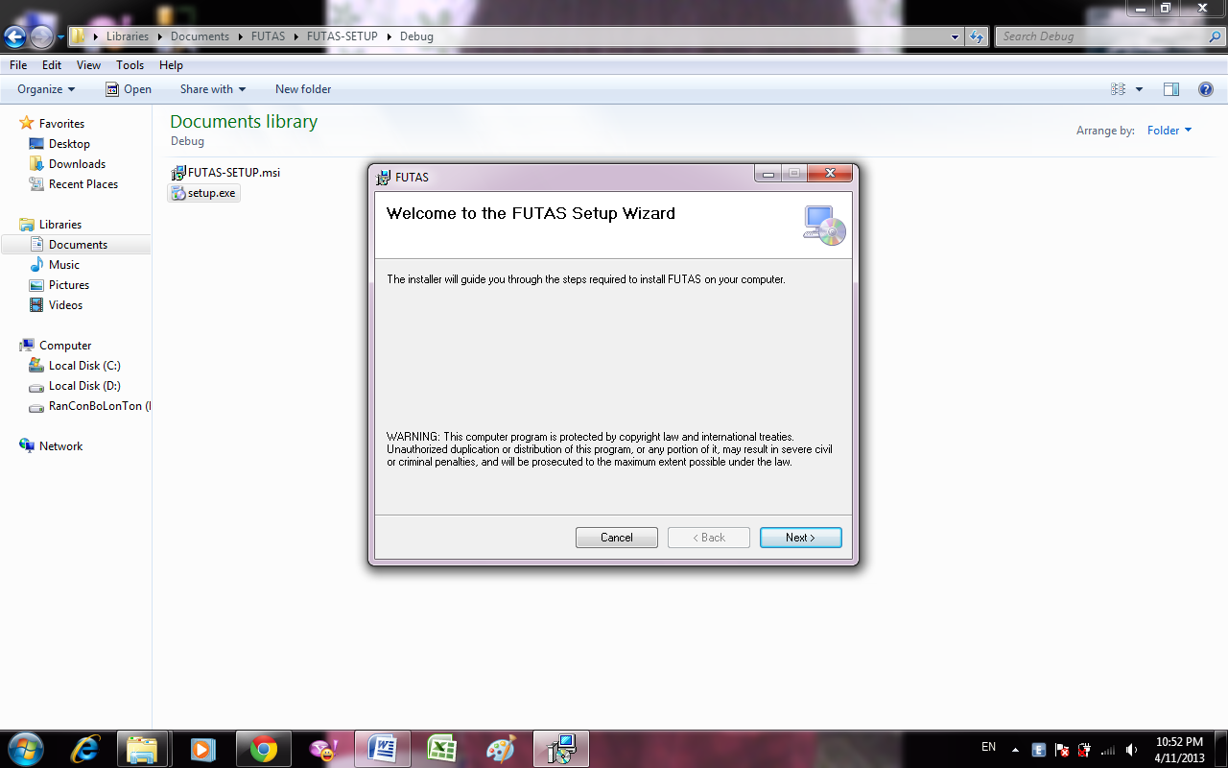

1. Click on next button

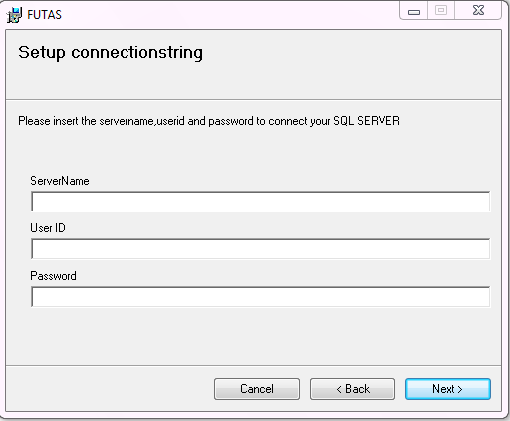

1. Insert server name, user id, password to connect SQL server
2. Click on next button

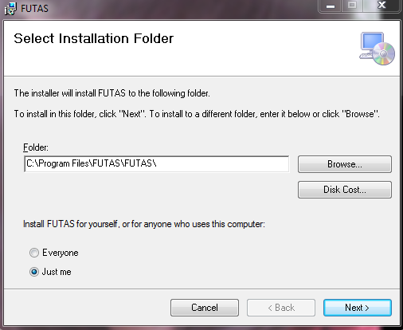

1. Browse folder to install
2. Select user
3. Click on next button

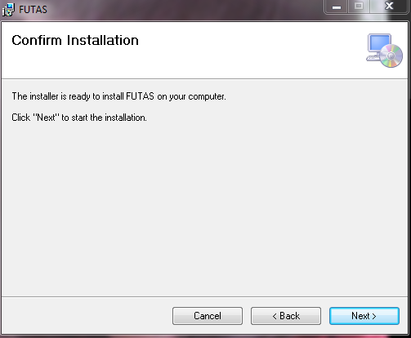

1. Click on next button



1. Wait for installing

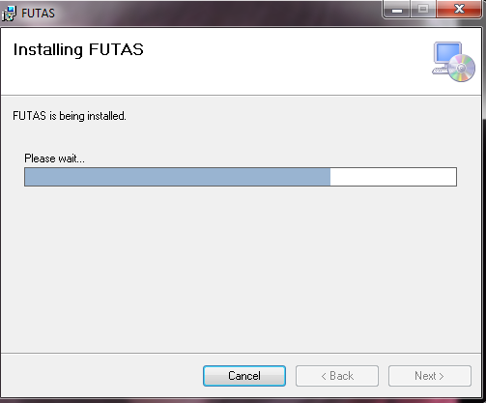

1. Installation completed

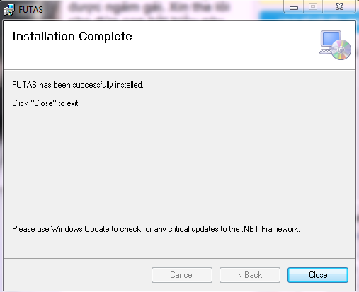

1. Run file FUTAS.exe in desktop
2. First time login

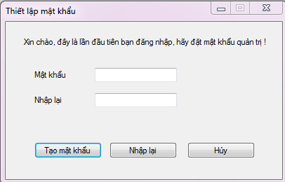

1. Insert password and confirm password in textbox (password’s length is at least 6 character)
2. Click on button create password and use application

**2. User guide**

**GUI**

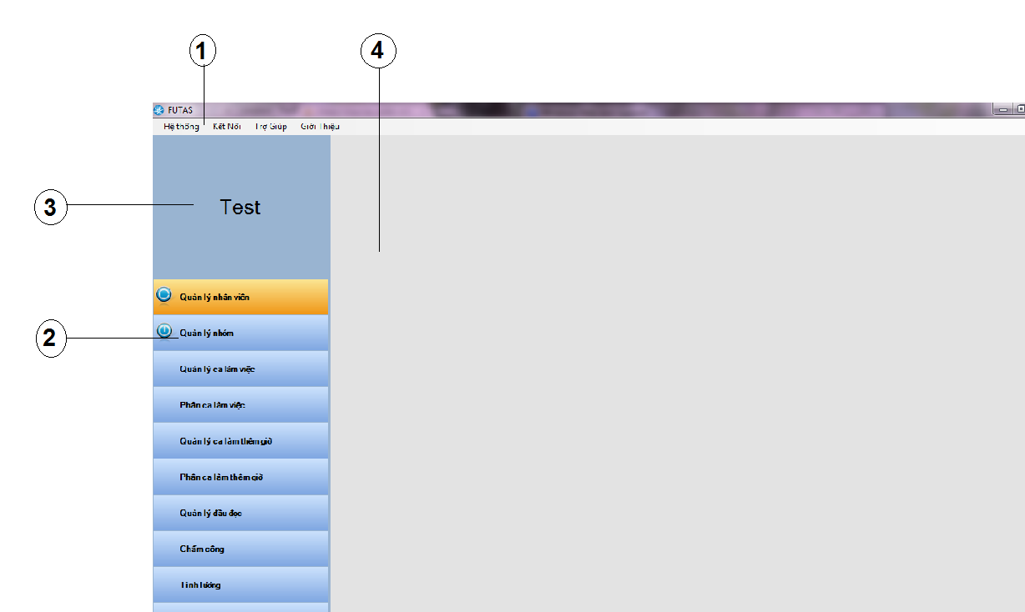

1 Menu bar

2 Toolbar

3 Logo

4 Modules form

**Login**



* Enter password of administrator
* Click on button login

**Menu bar**

* Click on system at menu bar to logout or login system
* Click on connect to connect reader
* Click on help to display file help
* Click on about to display FUTAS about

**Employee Management**

Click on “Management employee” at toolbar

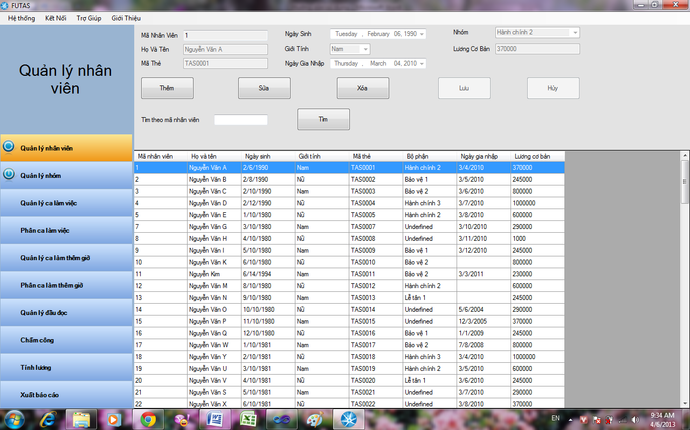

1. Add new employee

* Click on button Add 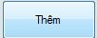 to add a new employee
* Employee is automatic raise
* Input full name of employee in textbox Họ và Tên (only alphabet character)
* Input card code in textbox mã thẻ (no special character)
* Select birth date of employee
* Select gender of employee
* Select join date of employee
* Select group of employee
* Input base salary of employee (per man-day)
* Click on button Save 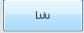 to completely add new 1 employee in database
* Click on button Cancel  to Cancel add new 1 employee
* Employee when add new in database will display at list of employee

1. Edit information of employee

* Click on button Edit 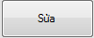 in order to Edit information of employee was selected
* Click on button Save  to completely edit employee at database
* Click on button Cancel  to Cancel edit employee

1. Delete employee

* Click on button Delete  in order to Delete employee was selected
* Display form confirm Delete 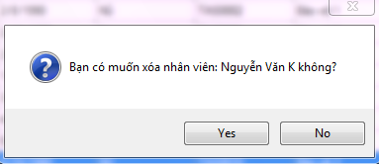
* Click on button Yes  in order to confirm Delete employee
* Click on button No  in order to Cancel Delete employee
* Employee was Delete will disappear in list of employee

1. Search employee

* Input code of employee in textbox Search
* Click on button Search 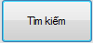 in order to find employee
* Employee is found will display at list of employee

**Management group**

Click on Management group at toolbar

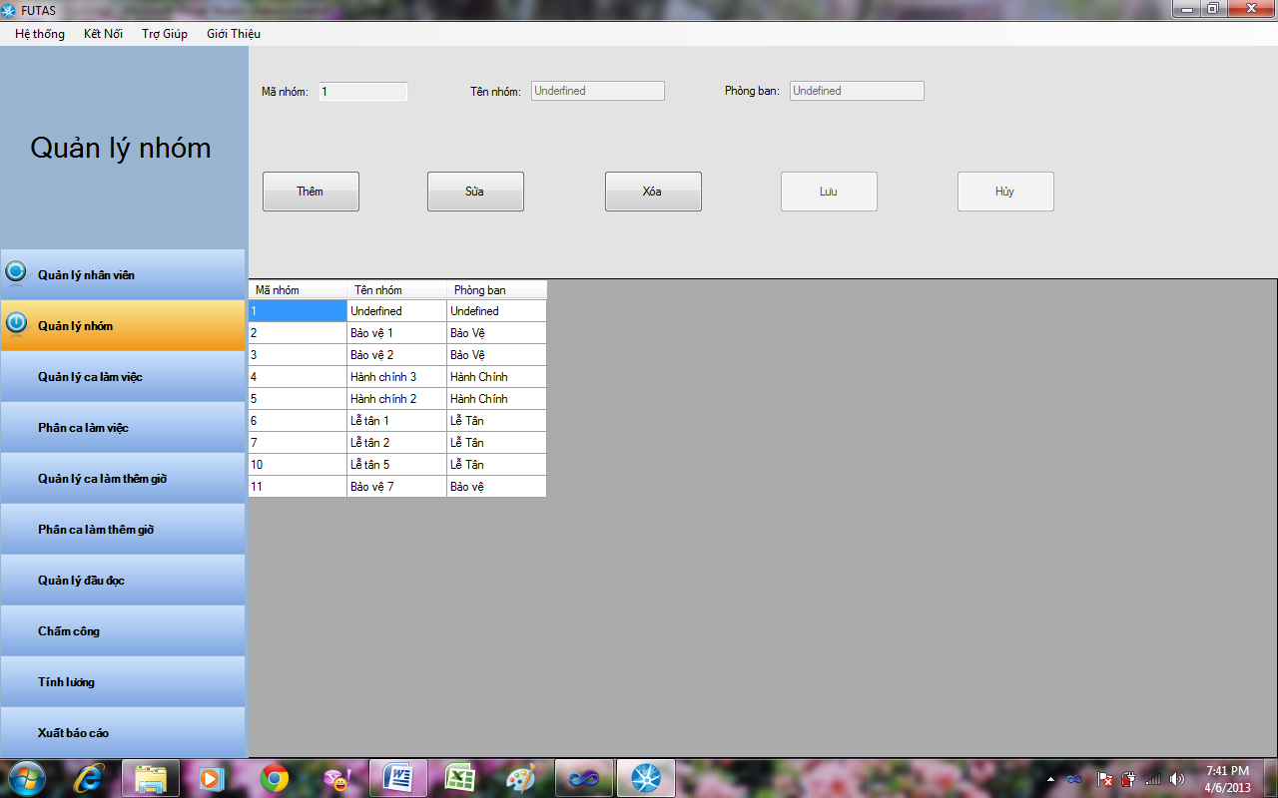

1. Add new group

* Click on button Add  in order to add new 1 group
* Code of group automatic raise
* Input name of group in textbox name of group
* Input Department of group in textbox Department
* Click on button Save  to completely add group in database
* Click on button Cancel  to Cancel add new group
* Group was added new will display at list of group

1. Edit group

* Click on button Edit  in order to edit group was selected
* Click on button Save  to completely edit group in database
* Click on button Cancel  in order to Cancel edit group

1. Delete group

* Click on button Delete  in order to Delete employee was selected
* Display form confirm Delete group 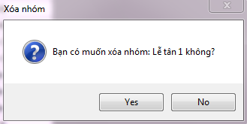
* Click on button Yes  in order to confirm Delete group
* Click on button No  in order to Cancel Delete group

**Management shift**

Click on Management Shift at toolbar

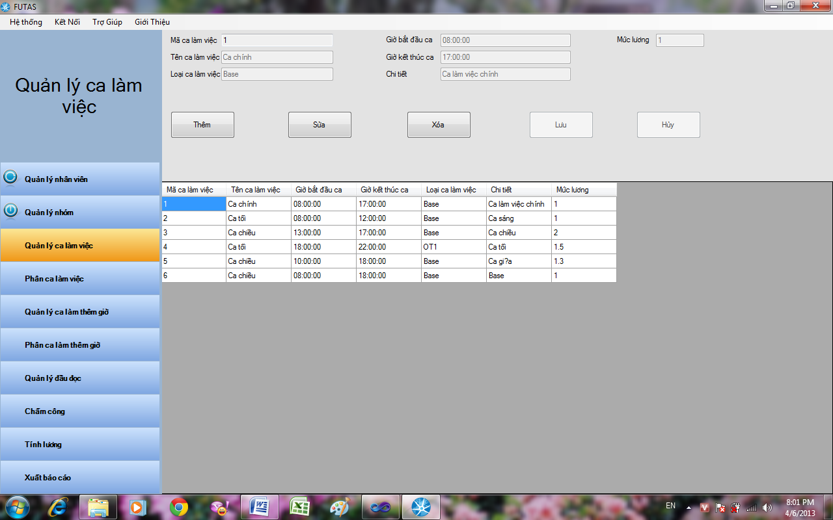

1. Add new shift

* Click on button Add  in order to add new 1 shift
* Code of shift automatic raise
* Input name of shift in textbox name of shift
* Input type shift in textbox type shift
* Input start time of shift in textbox start time shift(Time is hh:mm:ss)
* Input end time of shift in textbox end time shift(Time is hh:mm:ss)
* Input detail of shift in textbox detail
* Input salary level of shift in textbox salary level
* Click on button Save  to completely add new 1 shift in database
* Click on button Cancel  in order to Cancel add new shift

1. Edit shift

* Click on button Edit  in order to edit shift was selected
* Click on button Save  to completely edit shift in database
* Click on button Cancel  in order to Cancel edit shift

1. Delete group

* Click on button Delete  in order to Delete shift was selected
* Display form confirm Delete shift 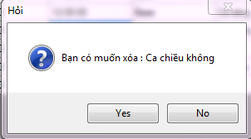
* Click on button Yes  in order to confirm Delete shift
* Click on button No  in order to Cancel Delete shift

**Distribute shift**

Click on Distribute shift at toolbar

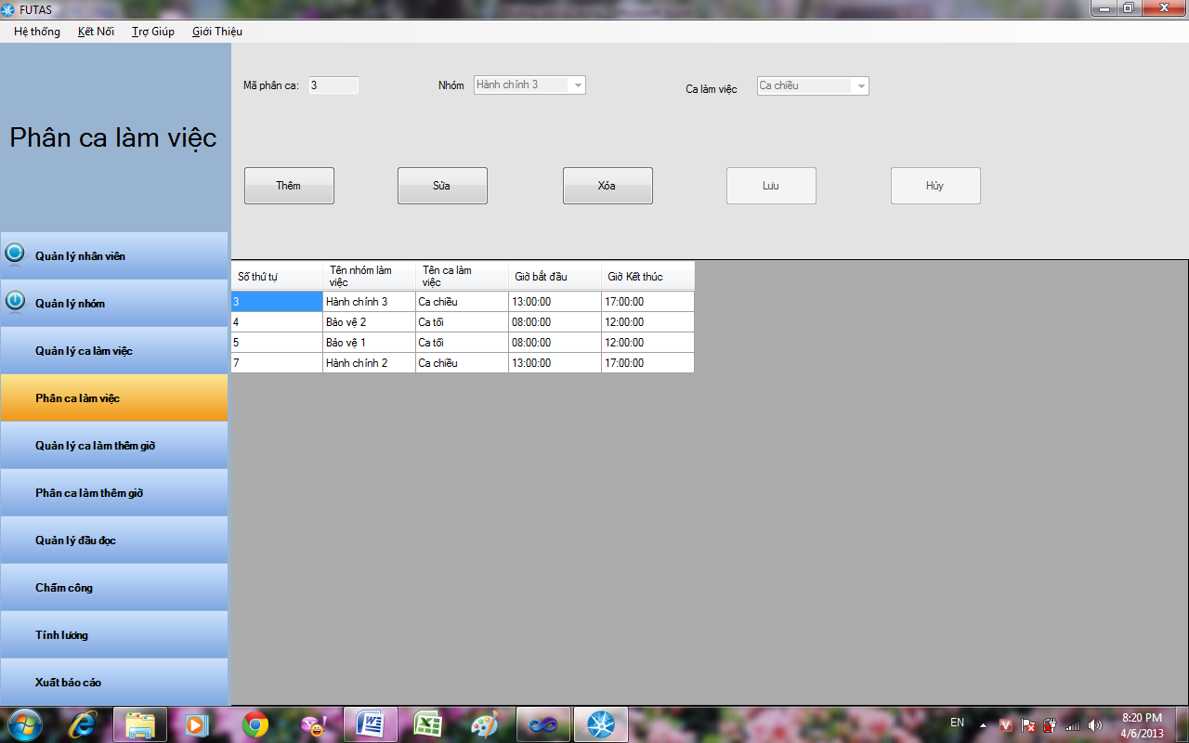

1. Distribute shift for group

* Click on button Add  in order to Distribute shift for 1 group
* Click on button Save  to completely Distribute shift for 1 group
* Click on button Cancel  in order to Cancel Distribute shift for 1 group

1. Edit Distribute shift for group

* Click on button Edit  in order to edit Distribute shift for group was selected
* Click on button Save  to completely edit Distribute shift for group
* Click on button Cancel  in order to Cancel edit Distribute shift for group

1. Delete Distribute shift for group

* Click on button Delete  in order to Delete Distribute shift for group was selected
* Display form confirm Delete Distribute shift for group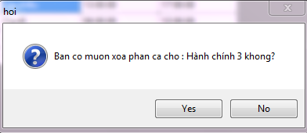
* Click on button Yes  to completely Delete Distribute shift for group
* Click on button No  in order to Cancel Delete Distribute shift for group

**Management shift overtime**

Click on Management shift overtime at toolbar

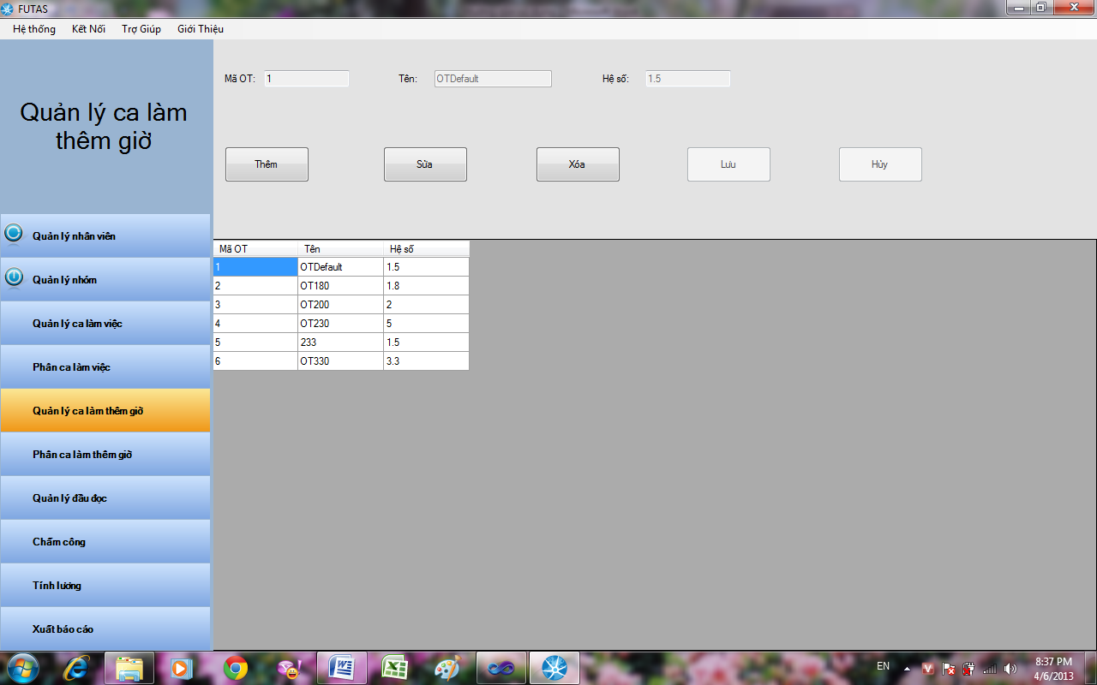

1. Add new shift Over time

* Click on button Add  in order to add new shift Over time
* Code of OT automatic raise
* Input name of shift Over time in textbox name of
* Input multiplier rate of shift Over time in textbox multiplier rate
* Click on button Save to completely add new shift Over time in database
* Click on button Cancel in order to Cancel add new shift Over time

1. Edit shift Over time

* Click on button Edit  in order to edit shift Over time was selected
* Click on button Save  to completely edit shift Over time
* Click on button Cancel  to Cancel edit shift Over time

1. Delete shift Over time

* Click on button Delete in order to Delete shift Over time
* Display form confirm Delete shift Over time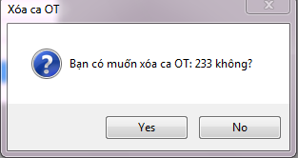
* Click on button Yes  to completely Delete shift Overtime
* Click on button No  in order to Cancel Delete shift Overtime

**Distribute shift overtime**

Click on Distribute shift Over time at toolbar



1. Distribute shift Over time for 1 employee

* Click on button Add  in order to Distribute shift Over time for 1 employee
* Code of Distribute shift automatic raise
* Input start time of shift add in textbox start time and select day(time is hh:mm:ss)
* Input end time of shift Over time in textbox end time and select day(time is hh:mm:ss)
* Select type of Over time
* Input code of employee in textbox code of employee
* Select status of shift Over time
* Click on button Save  to completely Distribute shift Over time for 1 employee
* Click on button Cancel  in order to Cancel Distribute shift Over time for 1 employee

1. Edit Distribute shift Over time

* Click on button Edit in order to edit Distribute shift Over time for employee was selected
* Click on button Save  to completely edit Distribute shift Over time
* Click on button Cancel  in order to Cancel edit Distribute shift Over time

1. Delete Distribute Over time

* Click on button Delete  in order to Delete Distribute shift Over time for employee was selected
* Display form confirm Delete Distribute shift Over time 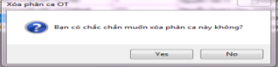
* Click on button Yes  to completely Delete Distribute shift Over time
* Click on button No  in order to Cancel Delete Distribute shift Over time

1. Show overtime by date

Select show overtime by day, month, year and click on button display

**Management reader**

Click on Management reader at toolbar

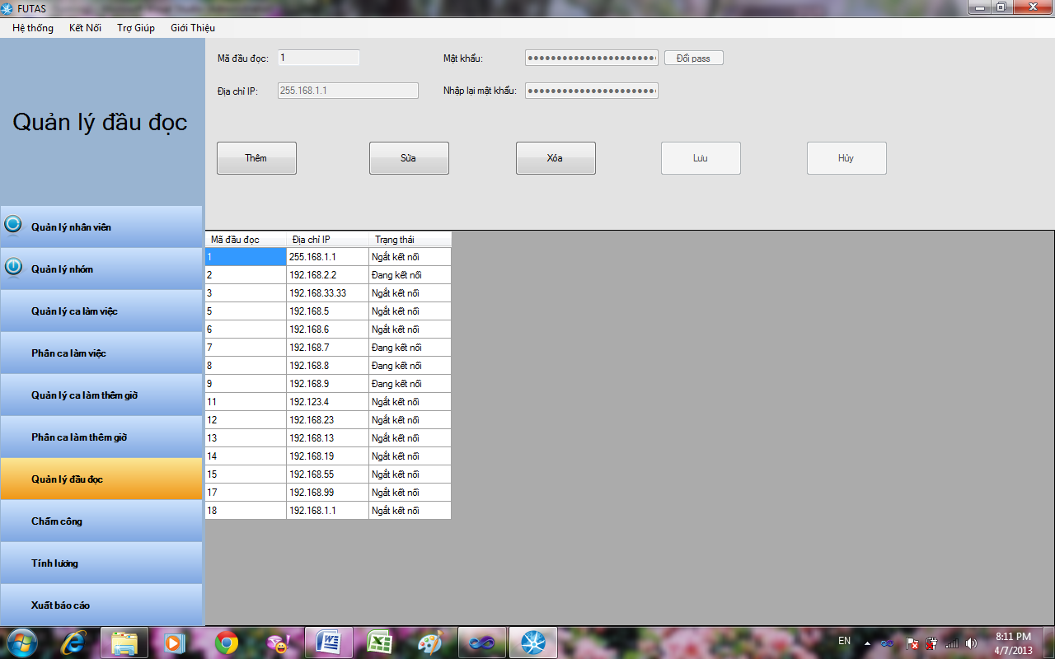

1. Add new reader

* Click on button Add  in order to add new reader
* Code of reader automatic raise
* Input IP address of reader in textbox IP address
* Input password of reader in textbox password
* Input confirm password of reader in textbox Input password again
* Click on button Save  to completely add new reader
* Click on button Cancel to Cancel add new reader

1. Edit reader

* Click on button Edit in order to edit information of reader
* Click on button change password  to change password of reader
* Click on button Save to completely edit reader
* Click on button Cancel  in order to Cancel edit reader

1. Delete reader

Click on button Delete  in order to Delete reader was selected

Display form confirm Delete reader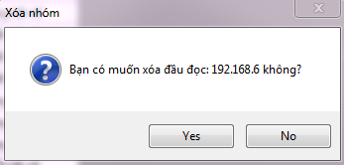

Click on button Yes to completely Delete reader

Click on button No  to Cancel Delete reader

**Timekeeping**

Click on timekeeping at toolbar

1. Timekeeping daily

Select Search daily



* Input code of employee Search in textbox Code of employee
* Select day find at textbox Day
* Click on button Search 

1. Timekeeping monthly

Select Search monthly

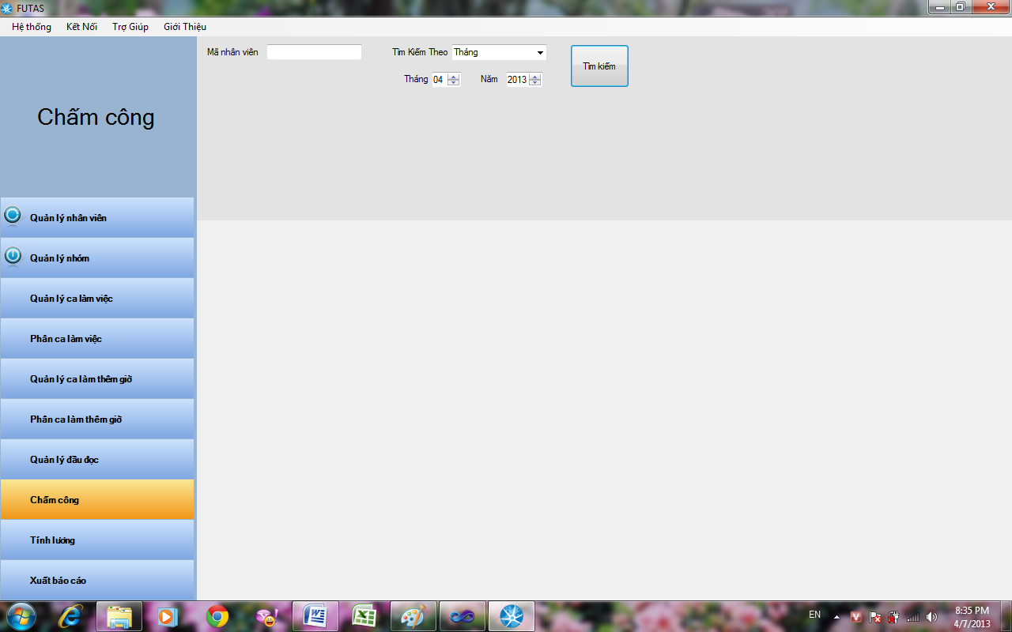

* Input code of employee Search in textbox Code of employee
* Select month find at textbox Month and year find at textbox Year
* Click on button Search 

1. Timekeeping yearly

Select Search yearly

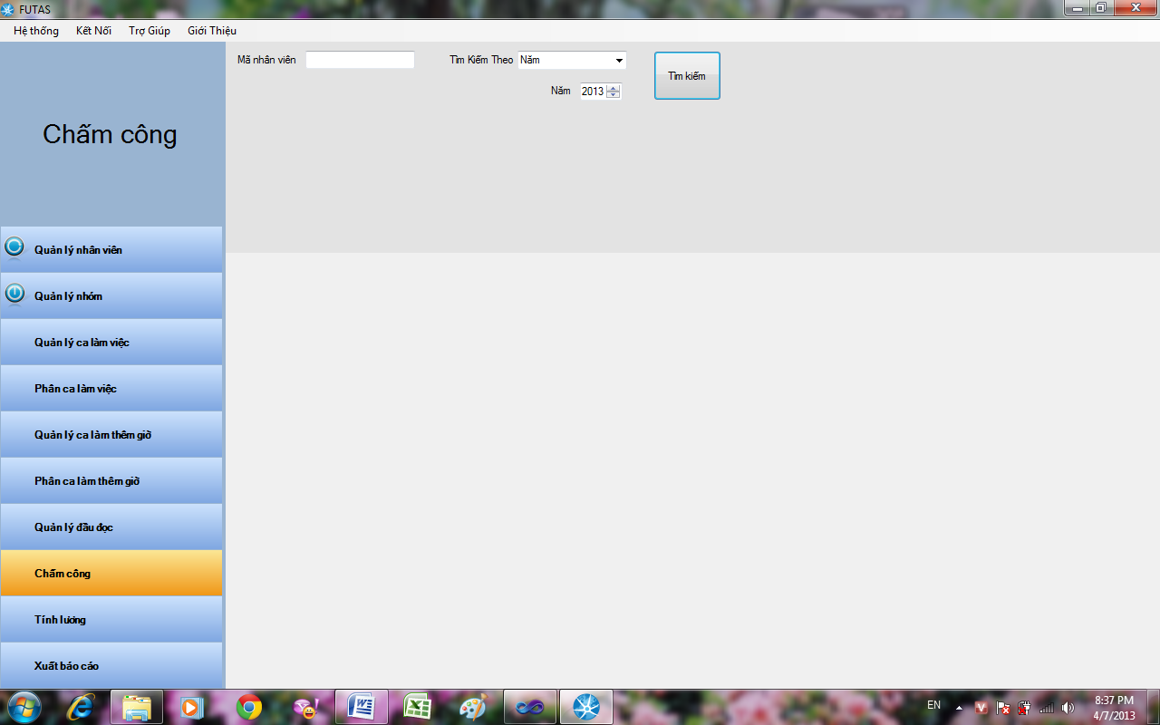

* Input code of employee Search in textbox Code of employee
* Select year find at textbox Year
* Click on button Search 

**Payroll**

Click on Payroll at toolbar



* Input code of employee at textbox code of employee
* Select month and year at textbox select month
* Click on button show salary  in order to show salary of employee was Input

**Dum report**

Click on Dum report at toolbar



* Select type report find at textbox select type report
* Click on button Search 

1. List of employee

Select list of employee in Click on button Search



Select group and Click on button 

* Toolbar 
* Click on  in order to back first page
* Click on  in order to back previous page
* Click on  in order to view next page
* Click on  in order to view last page
* Click on  in order to view previous report
* Click on  in order to stop rendering
* Click on  in order to refresh
* Click on  in order to print page
* Click on in order to view print page layout
* Click on in order to setup
* Click on in order to dump report
* Select scroll page 
* Search 

1. Select late statistic and Click on button 

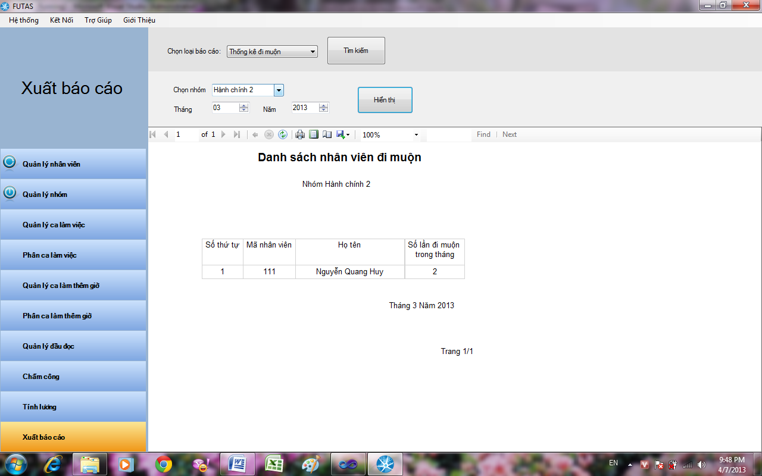

Select group at textbox select group

Select month at textbox select month and select year at textbox select year

Click on button find Display 